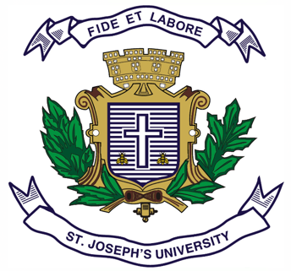
Registration Number:
Date & session:

ST. JOSEPH’S UNIVERSITY, BENGALURU -27
B.S.W – I SEMESTER
SEMESTER EXAMINATION: OCTOBER 2023
(Examination conducted in November/December 2023)
SW1121: Social Work Profession

(For current batch students only)

Time: 2 Hours Max Marks: 60
This paper contains TWO printed pages and THREE parts

PART-A
Answer any FIVE of the following 5 x 2 = 10
- Define Social Work.
- Mention the values in Social Work.
- Mention any two prominent figures who paved way for professional Social Work.
- What are the primary methods in professional Social Work.
- Write any two fields of Social Work.
- Expand IFSW and IASSW.
- What is zakat?

PART-B
Answer any FOUR of the following 4 x 5 = 20
- Write short notes on Octavia Hill and Ellen Gates Star.
- Explain any two social reform movements in India.
- Explain with suitable example the role of the government in promoting Social Welfare.
- Explain any five principles of Social Work with examples.
- Explain what makes Social Work a scientific profession.

PART-C
Answer any TWO of the following 2 x 15 = 30
- Explain the history of Social Work in the context of UK and USA.
- Write the Social Work ethics to be followed with clients. Give examples.

- Analyse the following case study and respond to the question following it:
Sunita Devi is a mid day meal cook in a school at Uttar Pradesh. She hails from the dalit community and is new to the job. One of the parents had created an issue with a dalit cook serving meal which Sunita herself reports. Talking about the alleged boycott, Sunita Devi said nothing “happened on the day I joined work and all the students had their meal properly”. “But, on the second day, a group of upper caste parents led by PTA president Narendra Joshi came to the school and asked their kids not to eat the meal for it was prepared by a Dalit cook,” Devi said.
According to her, the parents in question pressured the school principal to remove her from her job.
Devi also alleged that the accused persons tried to create an atmosphere of hatred against her in the village. “The upper caste parents not only tried to divide the children along caste lines, but also forced my colleague (an upper caste cook who had worked at the school for five years) to boycott me. She told me that villagers were pressuring her to refuse to have food or tea that I had prepared,” Devi said.
She said she will not give up the fight to get her job and self-respect back, but is willing to withdraw her FIR if she gets a written apology — and a promise — from the accused.
Source: https://theprint.in/india/uttarakhand-dalit-cook-fired-over-caste-files-case-against-upper-caste-parents-seeks-apology/792532/ dated 31December2021.
What are the social work values denied in this case? Explain how you as a Social Worker will intervene in this situation.

