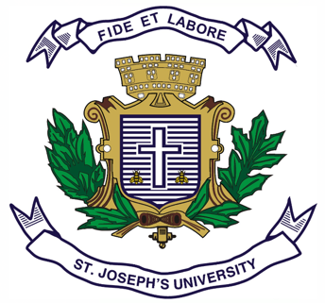
Registration Number:
Date & session:

ST. JOSEPH’S COLLEGE (AUTONOMOUS), BENGALURU -27
B.S.W – V SEMESTER
SEMESTER EXAMINATION: OCTOBER 2023
(Examination conducted in November/December 2023)
SW5122: Social Policy, Planning and Development

(For current batch students only)

Time: 2 Hours Max Marks: 60
This paper contains TWO printed pages and THREE parts

PART-A
Answer any FIVE of the following 5 x 2 = 10
- Define Social Policy.
- What is social planning?
- What is Economic Development?
- What is Human Development?
- Mention any two determinants of social policy.
- Write any two roles of the then planning commission.
- What is Sustainable Development?
PART-B
Answer any FOUR of the following 4 x 5 = 20
- Write the objectives of social policy.
- Write short notes on the types of social planning.
- Detail what are the prerequisites for Economic Development.
- Mention the role of UNDP in Human development.
PART-C
Answer any TWO of the following 2 x 15 = 30
- With examples, highlight the role and functions of Niti Ayog.
- Critically analyse the Right to Free and Compulsory Education Act as a social policy. Relate it to field realities based on your experience this semester and mention strategies in combating the issue of school drop outs.
- Who are the stake holders in policy making? Explain their importance with suitable examples.

