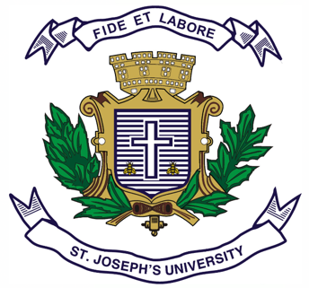
Registration Number:
Date & session:

ST JOSEPH’S UNIVERSITY, BENGALURU -27
MA JOURNALISM AND MASS COMMUNICATION – I SEMESTER
SEMESTER EXAMINATION: OCTOBER 2023
(Examination conducted in November /December 2023)
MC 7121: Introduction to Communication
(For current batch students only)

Time: 2 Hours Max Marks: 50

This paper contains ONE printed page and TWO parts

PART A

Answer any FIVE of the following in about 150 words each. (5X6 = 30)
- Foundations of communication
- Evolution of human communication
- Visual Literacy and Semiotics
- Communication and society
- Communication models
- Theorizing ‘Mass Media’
- Mass Media in India

Answer any TWO questions in about 500-600 words each. (2X10 = 20)
- Trace the evolution of human communication from the age of signs and symbols to the age of Mass Communication. Discuss with appropriate examples how the technological advancements and cultural changes have shaped the way humans communicate?

- Explain "Visual Literacy" and its significance in modern society. What is the role of perception, meaning, and semiotics in understanding visual communication? Explain with examples how visual elements are used in various media to convey messages.

- Compare and contrast the normative theories of mass media. With the help of examples, explain how they influence the role and responsibility of mass media in society.

- With the help of television as a mass communication tool, analyze the evolution and impact of mass media in India. Examine the role of Doordarshan and its influence on Indian society and culture. Discuss how television has shaped the media landscape in India, and the challenges and opportunities it presents.
***********

