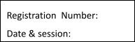

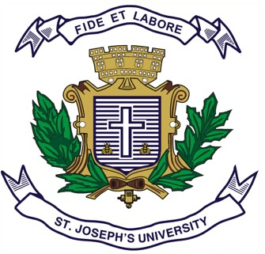
ST. JOSEPH’S UNIVERSITY, BENGALURU -27
MA JOURNALISM AND MASS COMMUNICATION – I SEMESTER
SEMESTER EXAMINATION: OCTOBER 2023
(Examination conducted in November /December 2023)
MC 7322: ADVERTISING
(For current batch students only)

Time: 2 Hours Max Marks: 50

This paper contains ONE printed page and TWO parts

PART A

Write short notes on any FIVE of the following in 100 words each. (5X6=30)

1. Public service advertising
2. Surrogate vs covert advertising
3. Ad clutter
4. Online ads
5. Integrated marketing communication
6. Influencer marketing
7. Ad pre-test and post-test
PART B

Answer any TWO of the following in 300 words each. (2X10=20)

8. Explain the advertising agency system and its operations.

9. Elucidate the different types of ad appeals with suitable examples.

10. Elaborate the steps to write a campaign and a creative brief?

11. What is the ASCI? Explain its code for self-regulation.

MC 7322_B_23

