**ST JOSEPH’S UNIVERSITY, BENGALURU - 27**

Registration Number:

Date & session:

**M.Sc. ENVIRONMENTAL SCIENCE AND SUSTAINABILITY – I SEMESTER**

**SEMESTER EXAMINATION: OCTOBER 2023**

**(Examination conducted in November/December 2023)**

**ES 7522: ENVIRONMENTAL CHEMISTRY AND ANALYTICAL METHODS**

 **(For current batch students only)**

**Time: 2 Hours Max Marks: 50**

**This paper contains TWO printed pages and THREE parts**

***Instruction: Draw diagrams wherever necessary***

**PART – A**

**Answer any FIVE of the following 5q X 2m = 10m**

1. What are the two key parameters commonly measured during the primary investigation of water samples in environmental analysis? Mention their importance for assessing water quality?
2. Explain the purpose of conducting a salt analysis and provide an example of an inorganic salt commonly encountered in environmental samples.
3. End point is always one or two drops more than equivalence point. Give reasons.
4. What are the selection rules for a diatomic molecule to show rotational transitions?
5. How many vibrational modes are possible for water molecule? Which among these are IR active?
6. Mention any two advantages of flame photometry.
7. Sketch the block diagram of UV single beam instrument.

**PART – B**

**Write explanatory notes on any FOUR of the following 4q X 5m = 20m**

1. Calculate the potential developed when 30.0 cm3 of 0.05 M Fe2+ is titrated against 10.0, 15.0 and 20.0 cm3 of 0.1 M Ce4+ in aqueous medium. Standard potentials of Fe and Ce couples are 0.68 V and 1.44V.
2. What is the principle of gravimetric analysis? Mention various applications of gravimetric analysis.
3. (i) 25 cm3 of HCl solution required 11.95 cm3 of 0.02 M Ba(OH)2 for exact titration.

Calculate molarity of HCl.

(ii) Discuss the advantages of conducting on-site field investigations as part of

environmental analysis. (3+2)

1. (i) Calculate the number of hyperfine lines seen in the case of a) CH3. b) .CH2CH3

radicals.

(ii) Discuss the Nernst glover radiation source in infrared spectrometer. (2+3)

1. The UV spectrum of acetone shows absorption at 279 nm and 198 nm. Identify the electronic transitions responsible for these absorptions.
2. Explain the technique involved in ion exchange chromatography.

**PART – C**

**Answer ALL of the following 2q X 10m = 20m**

1. a. 50 cm3 of 0.1 M NaOH is titrated against 0.2 M HCl. Calculate the pH at various stages in the reaction when 0.0, 10.0, 20.0, 25.0, 28.0, 35.0 cm3 of HCl solution is added. Draw a rough titration curve for the same and indicate a suitable indicator to determine the equivalence point.

**OR**

b. (i) Give the principle and working of TGA and DTA.

(ii) The following is the DSC curve of a polymer. Identify the regions marked A, B, C and D.

(6+4)

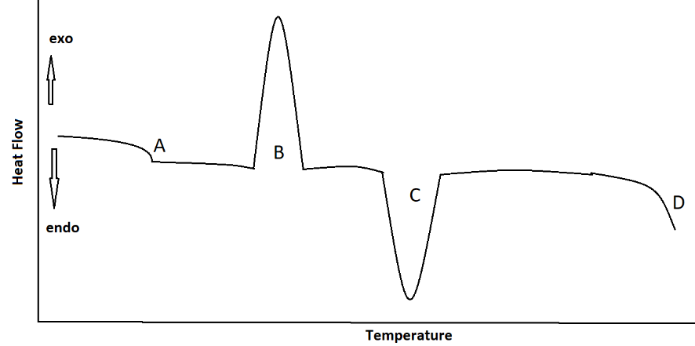

1. a. (i) The spectrum of HCl shows an intense absorption at a frequency of 8.7 x 1013 Hz.

Calculate the force constant of the bond (m of HCl is 1.628 x 10-27 kg).

(ii) Following are two constitutional isomers with the molecular formula C6H12O2.

Predict the number of signals in the 1H NMR spectrum of each isomer and show the splitting pattern of all the signals in each spectrum. (5+5)



**OR**

b. Discuss the operating principle of following instruments:

(i) X-ray fluorescence spectroscopy

(ii) Scanning electron microscope

(iii) CHNS analyser based on combustion method. (4+3+3)