Registration Number: Date & session:

ST. JOSEPH’S UNIVERSITY, BENGALURU -27 M.Sc (ZOOLOGY) – III SEMESTER
SEMESTER EXAMINATION: OCTOBER 2023
(Examination conducted in November/December 2023)

ZO 9423 –RESEARCH DESIGN AND METHODOLOGY
(For current batch students only)

Time: 2 Hours Max Marks: 50

This paper contains THREE printed pages and FOUR parts.

PART-A

Answer ALL of the following: 5 x 1 = 5

- is the first step in the research process.

- You should aim to publish your research in indexed journals.

- In research, a is the opposite of what you expect or your proposed explanation for a phenomenon.

- is a baseline statistic to compare means between two groups.

- is a global repository of all publications, genetic and protein sequence information available to the public.

PART B

Answer ALL of the following 5 x 2 = 10

- What is the main purpose of a hypotheses in research? What kind of research may not require hypotheses?

- How can preliminary studies useful in research?
- Briefly discuss the danger of designing a research project without literature review.
- To what agencies will you apply to procure funding in a) marine sciences, b) genetically modified crops, c) cancer, and d) ecology and environmental sciences?
- What is the difference between a Kruskal-Wallis test and an ANOVA.

PART C

Answer any THREE of the following 3 x 5 = 15

- Briefly explain what ethical components are required for research on humans.
- Demonstrate how you would reference: a) research paper, b) book, c) in-text citation with two authors and in-text citation with more than two authors, and d) a research paper with three authors, and e) a research paper with more than 4 authors.
- Briefly explain the relationship between reliability and validity of data with a diagram.
- Outline how the introduction and discussion should be related in a thesis.
- Use your knowledge of interpreting correlation vs. cause-and-effect to explain what is wrong with the interpretation made in the cartoon figure below?
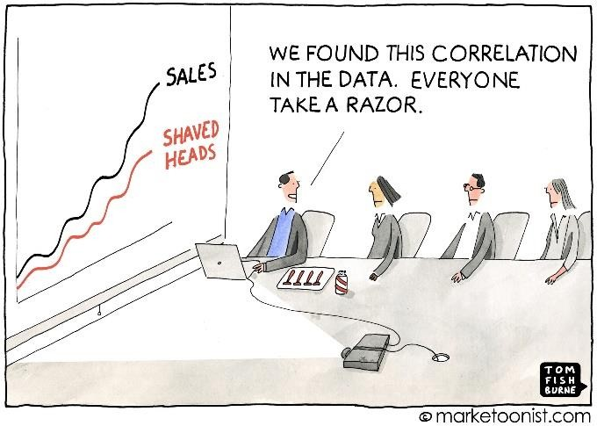
Fig for Q 16

PART D

Answer any TWO of the following 2 x 10 = 20

- Explain the major components of a research proposal. Provide a rationale for what should be included in each component and why.
- You are given the task of determining whether 10 species of Butterflies share a common ancestor. Briefly explain the computational pipeline and relevant software you would use to achieve this objective. Note: sequences for these 10 species exist in databases.
- What are the key differences between a thesis and a manuscript written for publication.

END

