Registration Number:
Date & session:
Registration Number:
Date & session:

ST. JOSEPH’S UNIVERSITY, BENGALURU -27
Open Elective – I SEMESTER
SEMESTER EXAMINATION: OCTOBER 2023
(Examination conducted in November /December 2023)
ZOOE2: Indian Wildlife Biology

(For current batch students only)

Time: 2 Hours Max Marks: 60

This paper contains FOUR printed pages and FOUR parts

PART-A

Answer ALL the questions. 20 X 1 = 20

- The RAMSAR wetland site present in Karnataka is Pala wetland (True/False)
- United Nations Environmental Program is the expansion of UNEP (True/False)
- Himalayas, Indo-Burma Region, ____________& Sundaland are examples of Biodiversity Hotspots
- “The Conservation of one species indirectly conserves and protects other species.” This definition best describes ______(flagship species/ Keystone species)
- Nagarahole National Park is located in Karnataka (True/False)
- Bannerghatta national park is an important wildlife corridor for elephant (True/False)
- Runn of Kutch Biosphere reserve is located in Kerala (True/False)
- Lake Chilka is located in ___________
- Horticultural practices and agriculture are not permitted in eco sensitive zones (True/False)
- _______________is the current Union Minister for the Ministry of Environment, Forest and Climate Change

Identify the class to which the animal belongs to

11 | 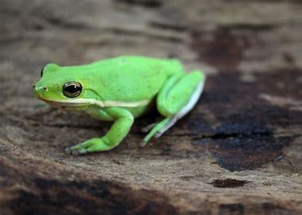 | - Amphibia  - Mammalia  - Reptilia  - Aves  - Osteichthyes
12 | 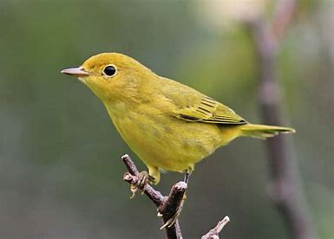 | - Amphibia  - Mammalia  - Reptilia  - Aves  - Osteichthyes
13 | 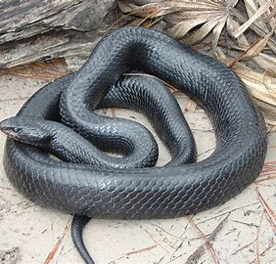 | - Amphibia  - Mammalia  - Reptilia  - Aves  - Osteichthyes
14 | 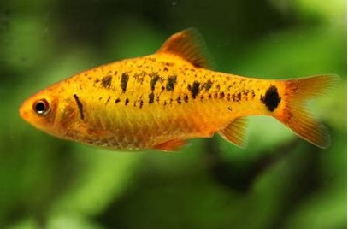 | - Amphibia  - Mammalia  - Reptilia  - Aves  - Osteichthyes
15 | 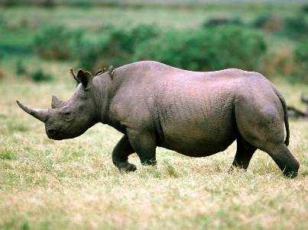 | - Amphibia  - Mammalia  - Reptilia  - Aves  - Osteichthyes

Identify the animal based on pugmark/ fecal pellet

16 |  | - Tiger  - Lion  - Jaguar  - cat
17 |  | - Cow  - Horse  - Rabbit  - Pig
18 |  | - Gorilla  - Rat  - Hippopotamus  - Elephant
19 |  | - Human  - Bear  - Deer  - Cow
20 |  | - Frog  - Hen  - Rat  - Aves

PART - B

Answer any FIVE of the following questions. 5 X 2 = 10

- What is a threatened species? Give two examples.
- Mention two ways in which common people can participation in Conservation.
- What are the criteria for qualifying an area as a Biodiversity Hotspot.
- List four national parks found in Karnataka
- How are mammals different from reptiles?
- What is community forestry?
- Write a note on competition with an example

PART - C

Answer any TWO of the following questions. 2 X 5 = 10

- List some Salient Features of Wildlife Protection Act​, 1972.
- Write a short note on mutualism and predation.
- Briefly explain Climate change. How does it affect biodiversity?
- Write a note on cheetah re-introduction in India.

PART - D

Answer any TWO of the following questions. 2 X 10 = 20

- Describe In-situ and ex-situ conservation methods for wildlife conservation with examples.
- Animals communicate in various ways among individuals of the same species or different species. Summarize the types with examples.
- Explain Keystone species and umbrella species with examples
***********

