Registration Number:
Date & session:
Registration Number:
Date & session:

ST. JOSEPH’S UNIVERSITY, BENGALURU -27
Open Elective – I SEMESTER
SEMESTER EXAMINATION: OCTOBER 2023
(Examination conducted in November /December 2023)
ZOOE 1: Zoology for Entrepreneurs
(For current batch students only)

Time: 2 Hours Max Marks: 60
This paper contains three printed pages and four parts
NOTE: Draw neat labeled diagram wherever necessary

PART-A

Answer ALL the following: 20 X 1 = 20
- Apis indica is
- Honey bee c) Fish
- Silk worm d) Prawn
- Cultivating silkworms and extracting silk from them is called -------------.
- Identify
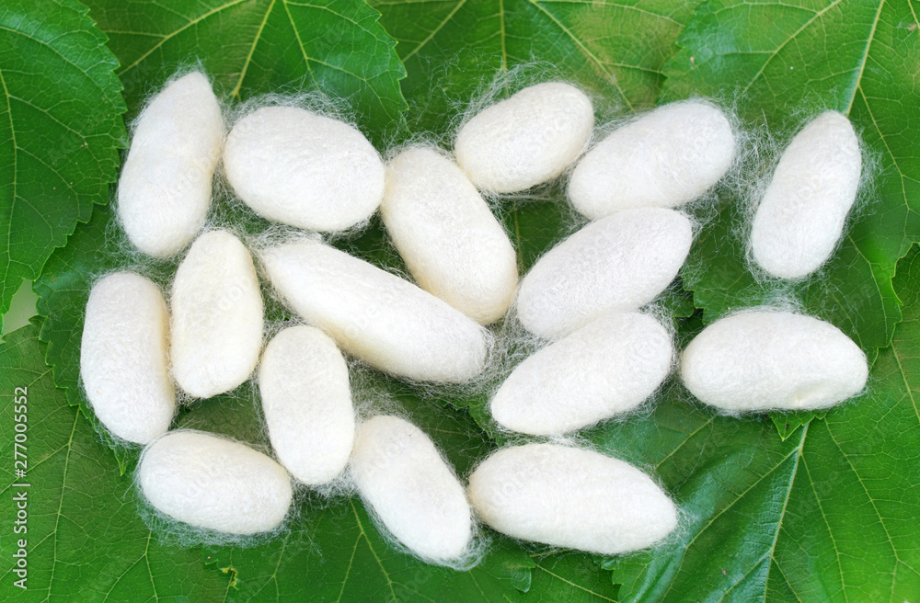
- Cocoon
- Nest
- Silkworm
- Thread
- Division of labor is seen in
- Silk worm c) Fish
- Prawn d) Honey bee
- Mention any two uses of honey.
- Identify the structure related to apiculture
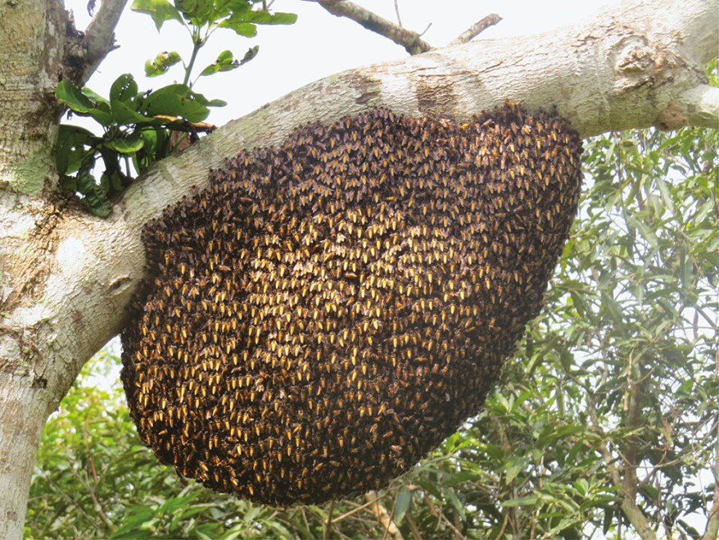

- The given animal belongs to
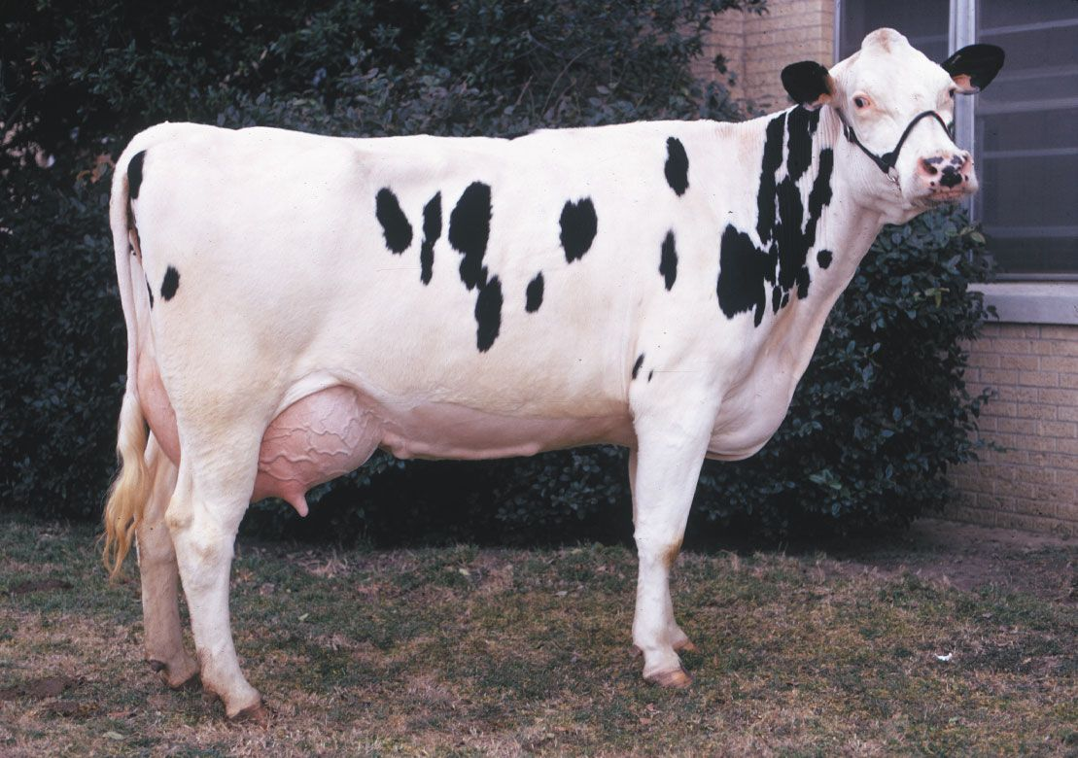
- Dairy
- Aquaculture
- Lac culture
- Apiculture

- Mention any one cattle disease.
- Conventional barn system is seen in
- Aquaculture c) Poultry
- Dairy d) Prawn culture
- Mention any two nutritive values of egg.
- Fowl cholera is a disease of
- Poultry c) Aquaculture
- Dairy d) Prawn culture
- Mention any two types of earthworms used in vermiculture.
- How vermicompost is useful to agriculture?
- Composite fish culture is culturing of five or six different types of fish species together. Yes, or No.
- Name any two common fishes used in culture.
- What is ornamental fish culture.
- Name the ornamental objects used in aquarium.
- Prawn lives in
- Land c) Air
- Water d) Forest
- Define lac culture.
- Mention any one host plant of lac insect.

PART-B

Answer any FIVE of the following: 5 X 2 = 10
- What is bee wax and add a note on uses of bee wax.
- Name any two diseases of poultry.
- Define aquaculture and fish seed.
- Mention any four milk products.
- Identify A and B
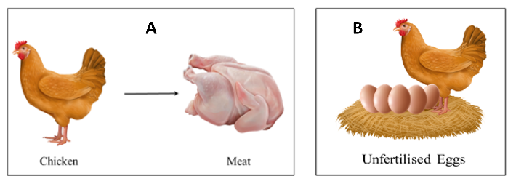

- List any two fishing crafts.
- The population of snail has to be controlled in aquarium, why?

PART-C

Answer any TWO of the following: 2 X 5 = 10
- Explain the life cycle of Honey bee.
- List any five different poultry breeds.
- Briefly explain pearl culture.
- Mention any five uses of lac.

PART-D

Answer any TWO of the following: 2 X 10 = 20

- Explain the morphology and life cycle of mulberry silk moth (Bombyx Mori).
- What is vermicomposting and explain the method.
- Explain loose housing system and conventional barn system of dairy.

----------------

