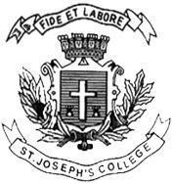
ST. JOSEPH’S COLLEGE (AUTONOMOUS), BENGALURU -27 B.Sc.–V SEMESTER
SEMESTER EXAMINATION: OCTOBER 2023
(Examination conducted in November /December 2023)
ZO 5123 – Non Chordates and Economic Zoology
(For current batch students only)
Time: 2 Hours Max Marks: 60
This paper contains TWO printed pages and FOUR parts

PART-A
Answer the following: 10 X 1 =10
- __________ is commonly called as sea mouse.
- Glacial control theory is proposed by _________.
- Turbellaria: Planaria :: Cestoda:_______.
- Classify the below animal to its respective class:

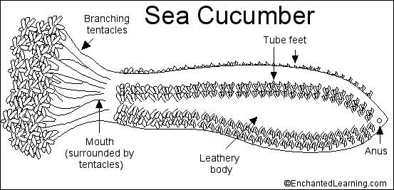

- Mention any two poultry breeds.
- The trochophore larva is associated with Annelida. TRUE/FALSE.
- The endocrine hormone influencing metamorphosis in insects is _______.
- Nautilus is an example for class _________.
- Define moriculture.
- What is Aquaponics?

PART B
Answer any FOUR of the following: 4 X 5 = 20
- Draw a neat labelled diagram of the externals of Unio.
- Describe the regeneration in Planaria with reference to child’s axial gradient theory.
- Illustrate the structure of Heteronereis.
- What are the class characteristics of Gastropoda and Bivalvia.
- What are the symptoms and preventive measures for
a) disease caused by Plasmodium vivax
b) Dengue
- Mention any 2 products of dairy industry and Poultry farming. Add notes on the challenges
faced by the dairy industry in Indian market.

PART C
Answer any THREE of the following: 3 X 10 =30
- Peripatus is called as the living fossil. Substantiate.
- Illustrate and explain the digestive system of earthworm.
- Why is it necessary to sanitize granaries? Add a note on rice weevil and pulse moth.
- Describe the morphology of Aurelia aurita.
- Explain the process of conjugation in Paramecium.

