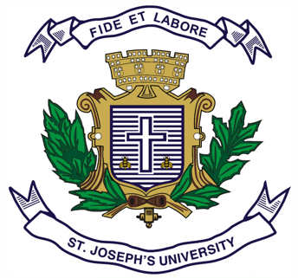

**ST.JOSEPH’S UNIVERSITY, BENGALURU -27**

**BA – I SEMESTER**

**SEMESTER EXAMINATION: OCTOBER 2023**

**(Examination conducted in November /December 2023)**

**OE 121: OPTIONAL ENGLISH**

**(For current batch students only)**

**Time: 2 Hours Max Marks: 60**

**This paper contains 2 printed pages and 4 parts**

1. You are **not permitted** to use a dictionary.
2. Please stick to the suggested word limit wherever possible.

**PART A**

**Answer the following questions in 150-200 words: (2x10=20)**

1. How did human language evolve? What distinguishes it from animal communication?
2. Referring to the texts you have encountered, examine how Indian authors represent ideas of social and political issues in their work. How do these representations contribute to your understanding of local and national concerns?

**PART B**

**Answer the following questions in 5-6 lines: (4x5=20)**

1. Transcribe the following line to IPA:
   1. Itsy bitsy spider
2. What are fricatives? Indicate the voice, place, and manner of articulation of at least 2 fricative consonant sounds.
3. What role does authorial intent play in interpreting a text? How much of the authorial intent do you think influences your interpretation of the text?
4. Discuss one experience in school which shaped Swami’s worldview?

**PART C**

**Answer ANY ONE of the following questions in 150-200 words: (1x10=10)**

1. Hutheesings’s and Ambedkar’s autobiographies show that they lived in two different Indias? What parts of the text made this distance evident?
2. What do kennings add to a text like Beowulf? Do you consider expressions like couch-potato and toothpaste modern day kennings? Why?

**PART D**

**Read the poem below by Michael Madhusudan Dutt:**

“Do not, O night sky! leave

tonight, with your lot of stars --

Once you go, blissful night!

So will my heartbeat!

Once the merciless sun is up

in the East,

The apple of my eye will lose her shine!

“Full twelve months she shed true tears

before Uma came home. What a balm!

In mere three days, tell me

Oh starry-tressed,

can one have a fill

of delight?

The golden glow of brass lamps

has driven afar darkness

within and without.

Words, the sweetest of creation!

have circled my ears.

“Darkness twice as thick, I know

will engulf this homestead

once you blow out this lamp...”

Entreated the Queen of Girish,

at the close of the ninth night...

**IV.A. Answer ANY TWO of the following questions in 5-6 lines: (2x5=10)**

1. What is the poet trying to imply with the phrase “sweetest of creation”?
2. What is the poet requesting of the night sky? Why?
3. Examine the use of exclamation marks. How do they affect the tone of the poem?