Registration Number:
Date & session:

ST.JOSEPH’S UNIVERSITY, BENGALURU - 27
BSC/BA/BCOM/BBA/BCA/BSW/BVC – I SEMESTER
END SEMESTER EXAMINATION: OCTOBER 2023
(Examination conducted in November /December 2023)
OE-OE 01: RE-READING COMICS: HEROES, HUMOUR, AND REPORTAGE
(For current batch students only)

Time: 2 Hours Max Marks: 60

This paper contains 2 printed pages and 2 Parts

INSTRUCTIONS:.
- You are allowed to use a dictionary.
- Please attempt all questions and stick to word-limits suggested.

- Read this comic strip from the series Flash Gordon,

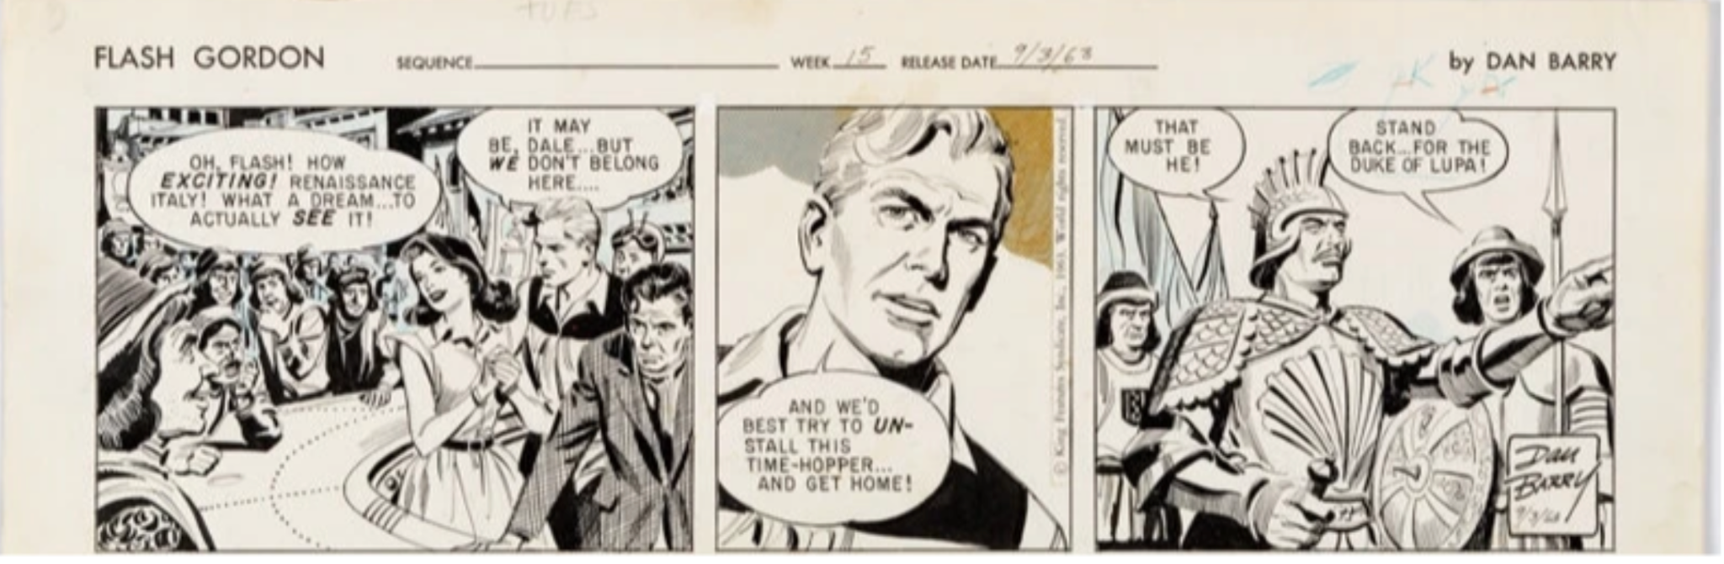

TRANSCRIPT
Dale Arden: Oh, Flash! How exciting! Renaissance Italy! What a dream… to actually see it!
Flash Gordon: It may be, Dale… but we don’t belong here…And we’d best try to uninstall this time-hopper…and get home!
Duke of Lupa: That must behe!
Attendant: Stand back for the Duke of Lupa!

I.A. Answer the following questions in FIVE sentences each: (3x5=15)
- How is the idea of Renaissance Italy established in visual terms?
- Do you notice anything interesting about the way Flash Gordon is drawn?
- What does the term time-hopper add to your understanding of the story?

II. Answer the following questions in 200-250 words each: (3x15=45)
- Are comics a good medium to tell science fiction stories? Give reasons for your answer.
- Comment on the way the individual pictures in the strip are drawn in relation to each other. What allows us to connect them and make sense of what is happening?
- In what direction is the story likely to progress? Who is going to be proven right: Dale who thinks this is a dream come true, or Flash who believes that things might go wrong? Which in your opinion is the more interesting direction?

