Registration Number:
Date & Session

ST JOSEPH’S UNIVERSITY, BENGALURU -27
III SEMESTER
SEMESTER EXAMINATION: OCTOBER 2023
(Examination conducted in November / December 2023)
OEOE 3 – MONSTERS, ZOMBIES AND THE IDEA OF HORROR

(For current batch students only)
Time: 2 Hours Max Marks: 60
This paper contains TWO printed pages and TWO parts

PART-A

A. Look at the following Garfield comic strip by Jim Davis:

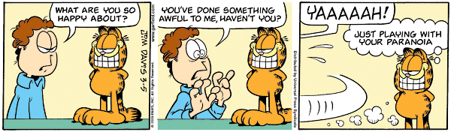
(The text in the panels read:
What are you so happy about?
You’ve done something awful to me, haven’t you?
YAAAAAH!
Just playing with your paranoia)

I.A. Answer the questions given below in 5 – 8 lines each: (3x5=15)

- Why does the boy in the comic strip get scared?

- The cat’s smile, usually something associated with happiness, inspires fear in the boy. Can you think of similar instances in horror books/movies/comics when conventionally pleasant things become reasons for fear? Elaborate.

3. Children often play an important role in horror movies and books. Why do you think this is the case?

PART-B

I.B. Answer the following questions in 200 – 250 words each: (3x15=45)

- Angelica Jade Bastién titles her essay on horror, “Horror is Not Defined by What Scares You”. Do you agree with that horror does not necessarily need to scare the readers/watchers? Why/why not? Justify your argument based on your reading and watching experiences of what you understand as horror.

- In the article “How K-Dramas breathed new life into Zombie Stories,” Regina Kim writes: Experts say that because zombies were once human beings, we often feel a deeper connection with them than with other types of monsters. We might recoil in horror, but that fear is often laced with sadness, sympathy and a sense of loss.
Do you share Regina Kim’s sentiments about a deeper sense of connection with zombies than with other monsters, and agree that K-dramas breathed new life into horror movies? Explain with examples.

- Which of the texts encountered in the Monsters, Zombies and the Idea of Horror classes stuck in your head the most? Why?

*****

