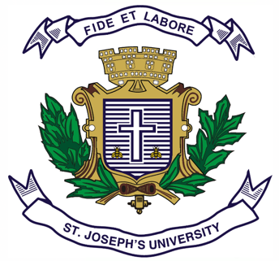
Registration Number:
Date & session:
ST JOSEPH’S UNIVERSITY, BENGALURU -27
MA JOURNALISM AND MASS COMMUNICATION – I SEMESTER
SEMESTER EXAMINATION: OCTOBER 2023
(Examination conducted in November /December 2023)
MC 7422: Public Relations

(For current batch students only)

Time: 2 Hours Max Marks: 50
This paper contains TWO printed pages and TWO parts

PART A

Answer any FIVE questions in 150 - 200 words each. (5X6=30)
  - What is Public Relations (PR)? Explain its key features and functions.
  - Define Corporate Social Responsibility (CSR). Why is corporate responsibility important in today's business environment? Provide examples of organisations that have successfully embraced CSR.
  - Compare the rhetorical, critical, and excellence perspectives of public relations. In what ways do these perspectives differ in their understanding of the role and impact of PR in organisations and society?
  - Write short notes on any TWO in 75-100 words each.
a. Co-creation and its types
b. Corporate identity, image and reputation
c. Public Relations as an activist medium
d. Corporate philanthropy
- Explain Tedlow's perspective on public relations and its relationship with public approval.
- Explain briefly any three models of PR with appropriate examples for each.
- What is the current PR scenario? How important is social media in PR today?

PART B
Answer any TWO questions in 300 words each. (2X10=20)
- What are the different steps involved in Public Relations process? Explain each one of them with the help of case studies.
- What are the various tools used by a PR Professional? Describe the skills required to be an effective PR professional.
- What is Reputation Management Framework? Explain the standardised framework to measure corporate reputation with suitable examples.
- Read the case study and answer the below mentioned questions.
Case Study: At the end of May 2015, Indian Food inspectors order Nestle India to recall a batch of Maggi Noodles from the northern Indian state of Uttar Pradesh claiming that tests have found Maggi instant noodles “unsafe and hazardous” and accused Nestle of failing to comply with food safety law. In response to these allegations, Nestle a global fast - moving consumer goods (FMCG) company, denied these allegation initially. They said on their website and social media accounts that there had been no order to recall any products. A statement on their website said that “The quality and safety of our products are the top priorities for our company. We have in place strict food safety and quality controls at our Maggi factories. We do not add MSG (Monosodium Glutamate) and lead to Maggi noodle, if present, may come from naturally occurring sources. We are surprised with the content supposedly found in the sample as we monitor the lead content regularly as a part of the regulatory requirements”.
Nestle continues to keep its customers up to date on the investigation into the safety of Maggi noodles in India. On the official Maggi noodles India Facebook page, Twitter and website, Nestle states that extensive testing reveals no excess lead in Maggi noodles. Nestle uses Twitter and Facebook to answer customers questions about the levels of MSG and lead found in their noodles. The company continues to re-assure customers that the noodles are safe and that they are a transparent company working closely with authorities in India to resolve the issue. Nestle explains the science behind the tests, what lead and MSG are and give an informative breakdown of the ingredients in their product.
Answer all the questions in 60-70 words each:
a. What is crisis communication?
b. Narrate the communication tactics used by Nestle to handle the crisis.
c. If you were the PR expert at Nestle, what would you do?
d. How would you react to Nestle’s approach as target audience/public?
e. Suggest an effective communication strategy for Nestle to regain the confidence of the customers.
********

