Registration Number:
Date & Session

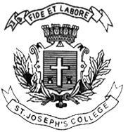
ST. JOSEPH’S COLLEGE (AUTONOMOUS), BENGALURU -27
B.VOC. DIGITAL MEDIA & ANIMATION – V SEMESTER
SEMESTER EXAMINATION: OCTOBER 2023
(Examination conducted in November /December 2023)
VOA 5323 – Emerging Media Technologies

(For current batch students only)

Time: 2 Hours Max Marks: 60
This paper contains ONE printed page and THREE parts

PART-A
Write short notes on any FIVE of the following questions in 100 words each: (5 X 5 = 25)
- Emerging media
- Automated journalism
- Web 3.0
- HMD
- Virtual Vietnam
- DoF
PART-B
Answer any TWO of the following questions in 200 words each: (2 X 10 = 20)
- Explain the types of VR with examples.
- Explain the similarities and differences between mainstream media and emerging media.
- Trace the history of VR.

PART-C
Answer any ONE of the following questions in 300 words each: (1 X 15 = 15)
- Discuss any three challenges of virtual reality and augmented reality.
- Elucidate any five applications of Immersive technology.

