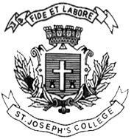
ST. JOSEPH’S COLLEGE (AUTONOMOUS), BENGALURU -27
Registration Number:
Date & Session
B.A. VISUAL COMMUNICATION–V SEMESTER
SEMESTER EXAMINATION: OCTOBER 2023
(Examination conducted in November /December 2023)
VC 5123 – Cinematography and Lighting

(For current batch students only)

Time: 2 Hours Max Marks: 60
This paper contains ONE printed page and THREE parts

PART-A
Write short notes on any FIVE of the following questions in 150 words each: (5 X 5 = 25)
- Visual storytelling
- Focus pulling
- White balance
- FPS
- Cutter stand
- Interlaced images

PART-B
Answer any TWO of the following questions in 300 words each: (2 X 10 = 20)
- Explain the 5Cs of cinematography.
- Elucidate the different aspect ratios.
- What are the equipment that can be used to control and shape light?

PART-C
Answer any ONE of the following questions in 450 words each: (1 X 15 = 15)
- Analyze how lighting can be used as a story element. Give suitable examples.
- Analyze in-depth the cinematography style of Conrad Hall.

