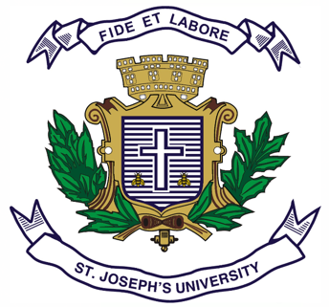
Registration Number:
Date & session:
Registration Number:
Date & session:

ST. JOSEPH’S UNIVERSITY, BENGALURU -27
B.A. VISUAL COMMUNICATION – III SEMESTER
SEMESTER EXAMINATION: OCTOBER 2023
(Examination conducted in November /December 2023)
VCDSE 5423: WORLD CINEMA

(For current batch students only)

Time: 2 Hours Max Marks: 60

This paper contains ONE printed page and THREE parts

- Write short notes on any FIVE of the following in about 150 words each. (5 x 5 = 25)

- Metropolis (1927)
- The Lumière brothers
- Baran (2001)
- French New Wave
- Dziga Vertov
- Christopher Nolan

- Answer any TWO of the following in about 250 words each. (2 x 10 = 20)

- Elaborate on the contributions of Akira Kurosawa to world cinema.
- Elucidate the significance of montage editing used in the film Man with a movie camera (1929).
- What is German Expressionism film movement? Explain with examples.

- Answer any ONE of the following in about 350 words. (1 x 15 = 15)

- The regional cinema of India has broken the language barriers in the last decade due to the OTT boom. Discuss.
- Write brief notes on
- All about my mother (1999)
- Not one less (1999)

