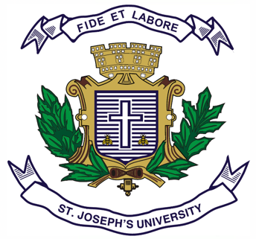
ST.JOSEPH’S UNIVERSITY, BENGALURU-27
Registration Number:
Date & session:
B.A. (HISTORY) – III SEMESTER
SEMESTER EXAMINATION: OCTOBER 2023
(Examination conducted in November/December 2023)

HS 3222: FREEDOM MOVEMENT IN KARNATAKA [1800-1947]
(For current batch students only)
Time: 2 Hours Max Marks: 60
This question paper has 1 printed page and 4 parts

SECTION - A
Answer any 2 of the following (2 x 10 = 20)
1. Sketch the role of Baba Saheb of Nargund in his struggle against the British.
2. Enumerate the role played by Kannadigas in the Quit India Movement of 1942.
3. Describe the unification movement of Karnataka from 1924 – 1956.

SECTION - B (5 + 5 = 10)
4. Mark on the outline map provided the following places and write their historical importance. 1. Dharwad 2. Ankola 3. Belgaum 4. Mangalore 5. Mysore

SECTION - C
Answer any 4 of the following (5 x 4 = 20)
5. Factors for the rise of Nationalism.
6. Swadeshi Movement of 1905.
7. Belgaum Session of the Congress.
8. Circumstances leading to Salt Satyagraha.
9. Shivapura Congress of 1938.
10. Palace Satyagraha.
SECTION - D

Answer any 5 of the following questions (2 x 5= 10)
11. Kittur Chennamma.
12. Gangadhar Rao Deshpande.
13. Hardekar Manjappa.
14. Hindustan Seva Dal.
15. Isur Tragedy.
16. Fazl Ali Committee.
17. Role of Press in the National Movement of Karnataka.

