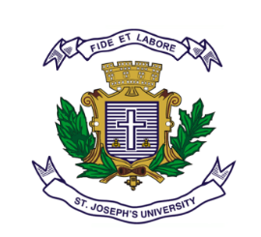
ST JOSEPH’S UNIVERSITY, BENGALURU -27
Registration Number:
Date & Session
OPEN ELECTIVE COURSE – III SEMESTER
SEMESTER EXAMINATION: OCTOBER 2023
(Examination conducted in November /December 2023)
PYOE3: YOUTH, GENDER AND IDENTITY
(For current batch students only)

Time: 2 Hours Max Marks: 60

This paper contains ONE printed page and TWO parts

PART-A
Answer any SIX of the following questions 6x5=30

- Write the difference between youth and adult
- Explain the concept of multiplicity of identity.
- Write the difference between gender and sex.
- What is the role of society in identity formation in youth?
- How do we encourage non-gender stereotyped attitude in youth?
- Write short note on Juvenile Justice Act 2015.
- What is work life balance? Explain its importance.
- What is women’s empowerment? Explain the current status of women’s empowerment in India.

PART-B

Answer any THREE of the following questions 3x10=30

- Is it solidarity or conflict that characterizes intergenerational relationships between parents and children?
- “Youth is the time of rebellion” Critically evaluate the statement.
- Explain the influence of cultural and globalization on gender identity.
- Explain the various factors determining aggression and violence in youth.
- Reflect on the following statement “Identity is a paradoxical experience”.

*********

