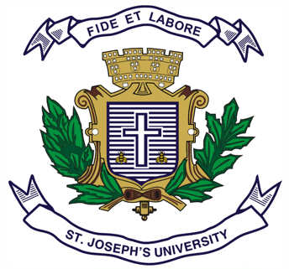

ST JOSEPH’S UNIVERSITY, BENGALURU -27
Registration Number:
Date & session:
M.Com – 2nd SEMESTER
SEMESTER EXAMINATION: APRIL 2024
(Examination conducted in May / June 2024)
MCO 8420: RESEARCH METHODOLOGY
(For current batch students only)

Time- 2 Hours Max Marks-50

This paper contains _____ printed pages and three parts
Part A
I. Answer any two of the following (2x5 = 10 Marks)
- Differentiate between quantitative research and qualitative research.
- Outline the steps involved in developing the research proposal.
- Briefly explain on observation research.

Part B
II. Answer any two of the following (2x15 = 30 Marks)
- What is sampling? Discuss different types of probability and non-probability sampling techniques.
- Write a note on preparing the data for analysis on the following with example:
- Editing (5 marks)
- Coding (5 marks)
- Tabulation (5 marks)
- Discuss the different types of tests used in parametric and non-parametric tests.

Part C
III. Answer the following (1x10 = 10 Marks)
- “Exploratory research aims to uncover new insights, understand complex phenomena, and identify potential areas for further study.”

Explain the different methods of exploratory research in light of the above statement.

