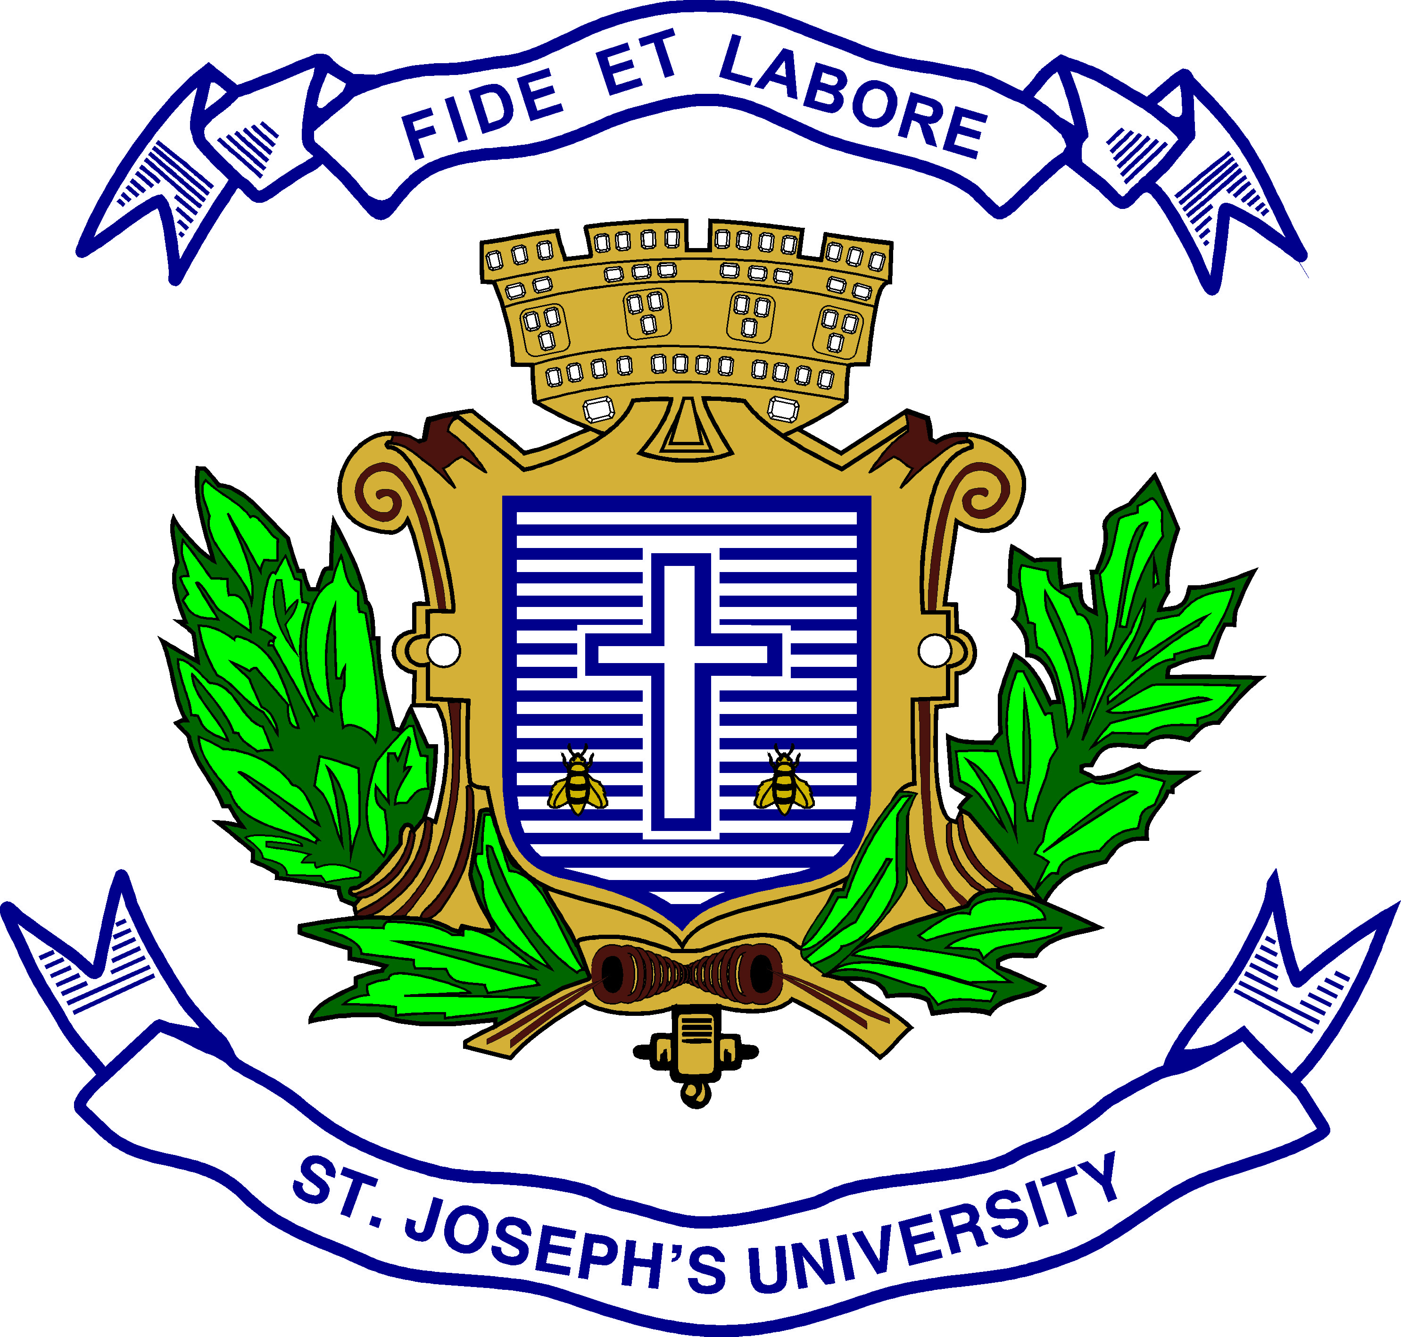
Registration Number:
Date & Session:
ST. JOSEPH’S UNIVERSITY, BANGALORE-27
M.COM – II SEMESTER
END SEMESTER EXAMINATION: April 2024
(Examination conducted in May/June 2024)
MCO8520 : DIGITAL MARKETING
(For current batch students only)
Time : 2 Hours |  | Max Marks : 50
This paper contains two printed pages and three parts
Part A
- Answer any Two of the following. 2x5=10 Marks

- Differentiate between traditional marketing and online marketing.
- Briefly explain the media options available for marketers.
- What is affiliate marketing? List any three advantages.

Part B
- Answer any Two of the following: 2x15=30 Marks

- Discuss content marketing in brief. Why and how content is important to online business?
- Discuss any three social media marketing platforms with examples.
- a) Briefly explain the online pricing models. (5m)
b) Briefly explain the characteristics of social media. (10m)

Section C
- Answer the following: 1x10=10 Marks

7. As the owner of a new online apparel store, you're not having a strong relationship with your customers.
Question: Explain what strategies you can implement to maintain an effective electronic public relation with your customers.

