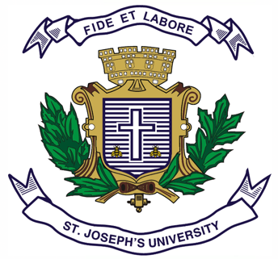
Registration Number:
Date & session:
Registration Number:
Date & session:

ST.JOSEPH’S UNIVERSITY, BENGALURU -27
M.COM– IV SEMESTER
SEMESTER EXAMINATION: APRIL 2024
(Examination conducted in MAY / JUNE 2024)
MCODEF0420- FINANCIAL AND COMMODITY MARKETS
(For current batch students only)

Time: 2 Hours Max Marks: 50
This paper contains TWO printed pages and THREE parts

Section A
I. Answer any TWO of the following (2 X 5 = 10 marks)
- Explain the Black Scholes Model?
- What are the key differences between Commodity and Financial Derivatives?
- Write a short note on:
- Warehouse Receipts
- Exotic options

Section B
II. Answer any TWO of the following (2 x 15 = 30 marks)
- Discuss the importance of derivatives market and explain the different order types in derivatives market. (8 +7 marks)
- What are options? Explain the types of options with a suitable example.
- What is Risk? Explain the types of Risk.

Section C
III. Answer the following (1 X 10 = 10 marks)
- Mr. Gupta is a farmer who grows wheat and wants to sell it at a future date. He has two options: a forwards contract and a futures contract. However, he is confused about which one to choose. As a Financial expert, explain to Mr. Gupta the difference between the two based on the following parameters and recommend to him the suitable option:
- Standardization
- Counterparty risk
- Liquidity
- Margin
- Regulation.

