ST. JOSEPH’S UNIVERSITY, BENGALURU -27 B.A COMMUNICATIVE ENGLISH – II SEMESTER END SEMESTER EXAMINATION: MAY 2024 CE 221: COMMUNICATIVE ENGLISH
Registration Number:
Date & Session:
Time: 2 hours Max Marks: 60

Instructions:
- This question paper has FOUR pages and THREE sections.
- Do not exceed the suggested word limit

- Examine the following panels from Joe Sacco’s Safe Area Goražde.

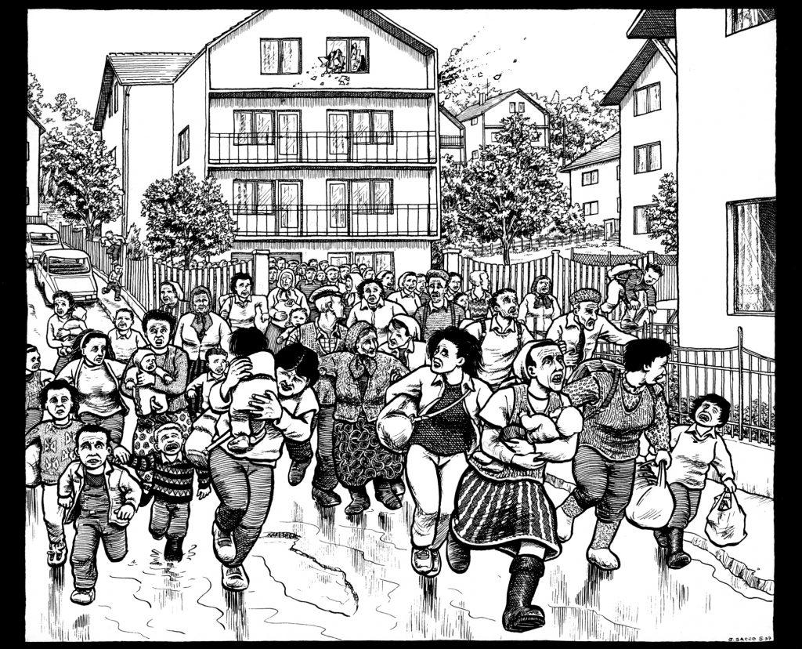

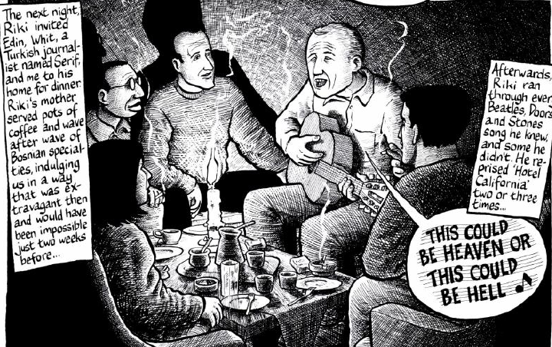

Now read the following excerpt from a paper titled Things and Trauma in Joe Sacco’s Safe Area Goražde by Dr. Shalini Srinivasan.

Sacco's narrative pays great attention to the everyday, the mundane – eating, drinking, smoking, getting firewood. This sense of fullness and detail as truth is a repeated motif in most critical treatments of Sacco’s work. Jeff Adams remarks on Sacco’s “detailed etched finish” and “extensive narration texts”, while Andrea Lunsford and Adam Rosenblatt comment that “Sometimes he zooms in so close that we feel as if we have invaded the personal space of his interviewee”. In a presentation, Sacco himself describes an attempt to make his art “loud”. Many of the individual testimonies in the comic have, at their centre, quotidian (of or occurring every day; daily) concerns – getting food, for example. Rose Brister, in her analysis of Sacco’s earlier Palestine, equates Sacco’s search for the “essential truth” of a situation with “a people’s everyday life”. Sacco’s Real Truth, in other words, lies in the plenitude and density of information, especially everyday details.

- Answer the following questions in FIVE-EIGHT sentences. (3x5=15)

- Examine the two illustrations in light of what the author says about “essential truths of a situation” – how does the reader engage with them both?

- What would you say to someone insisting that ONLY ONE of the illustrations from above tells the ‘real’ truth about Goražde?

- Identify FIVE fricatives in the line “This could be heaven or this could be hell” and also identify the voicing, place of articulation and manner of articulation in each case.

- Read the following excerpt from an essay called The Gatekeepers Who Get to Decide What Food Is “Disgusting” by Jiayang Fan and answer the questions below.

As a young Army recruit, my mother ate the rats that scurried outside the granary she guarded, and for years she ate kernels of rice that she found on the ground—something I was told by other adults never to do. To be the first member of my family spared the pangs of hunger was to live through an epochal transition that felt like cultural transformation.

Still, the threat of deprivation hung over our lives like the dangling carcasses in the village wet markets. At those markets, my mother traded her extra grain coupons—which she began to receive after becoming an Army doctor—for eggs, an expensive protein in the hierarchy of foods.

Shortly before I began first grade, my mother stopped feeding me the rice porridge and the pickles that she and my grandmother ate every morning and started me on a special breakfast of what she called “brain foods”: a warm, viscous puddle of milk, bobbing with chunks of raw egg yolk. Disgust welled up in me, but it contended with other blades that were necessary for survival: the shame of ingratitude, and the fear of disobedience. I ate the brain foods every morning for two interminable years.

Even so, disgust did not leave a lasting mark on my psyche until 1992, when, at the age of eight, on a flight to America with my mother, I was served the first non-Chinese meal of my life. In a tinfoil-covered tray was what looked like a pile of dumplings, except that they were square. I picked one up and took a bite, expecting it to be filled with meat, and discovered a gooey, creamy substance inside. Surely this was a dessert. Why else would the squares be swimming in a thick white sauce?

I was grossed out, but ate the whole meal, because I had never been permitted to do otherwise. For weeks afterward, the taste festered in my thoughts, goading my gag reflex. Years later, I learned that those curious squares were called cheese ravioli.

- Answer ANY THREE of the following questions in 100-150 words each. (3x10=30)

- The subhead for this article is as follows: “At the Disgusting Food Museum, in Sweden, where visitors are served dishes such as fermented shark and stinky tofu, I felt both like a tourist and like one of the exhibits.” Based on this, the title of the article, and the extract above— where do you see the rest of this story going?

- If you were to write a feature story about disgusting foods, how would you begin? Why?

- What are affricates? How are they different from plosives and fricatives? Locate two words which contain affricates in the images from Safe Area Gorazde and provide the voice, place and manner of articulation for each.

- Why do you suppose the writer tells us about her mother’s relationship with food? How does this detail contribute to your reading of the feature story?

- Respond to the prompt given below in 150-200 words. (15 marks)

- Bitter gourd in my language

*******

