Register Number:
Date & session:

ST JOSEPH’S UNIVERSITY, BENGALURU -27
II SEMESTER
END SEMESTER EXAMINATION: APRIL 2024
(Examination conducted in May / June 2024)
JNI OE 02: Success with Content Writing

(For current batch students only)

Time: 2 Hours Max Marks: 60
This paper contains FIVE printed pages and THREE parts

PART-A
- Read the extract from the article, “How Hollywood writers triumphed over AI – and why it matters” by Dani Anguiano and Lois Beckett from the Guardian.
Hollywood writers scored a major victory this week in the battle over artificial intelligence with a new contract featuring strong guardrails on how the technology can be used in film and television projects. One of the longest labor strikes in Hollywood history came to an end on Tuesday after the Writers Guild of America (WGA) approved an agreement made with the Alliance of Motion Picture and Television Producers.
One of the most closely watched aspects of negotiations was the use of artificial intelligence, amid concerns from both writers and actors that unchecked AI could dramatically reshape Hollywood and undermine their roles, pitting artists against robots in a battle over human creativity.
With terms of AI use finally agreed, some writers are breathing easier – for now – and experts say the guidelines could offer a model for workers in Hollywood and other industries. The writers’ contract does not outlaw the use of AI tools in the writing process, but it sets up guardrails to make sure the new technology stays in the control of workers, rather than being used by their bosses to replace them.
The new rules guard against several scenarios that writers had feared, comedian Adam Conover, a member of the WGA negotiating committee, told the Guardian. One such scenario was studios being allowed to generate a full script using AI tools, and then demanding that human writer complete the writing process.
Under the new terms, studios “cannot use AI to write scripts or to edit scripts that have already been written by a writer”, Conover says. The contract also prevents studios from treating AI-generated content as “source material”, like a novel or a stage play, that screenwriters could be assigned to adapt for a lower fee and less credit than a fully original script.
Simon Johnson, an economist at MIT who studies technological transformation, called the new terms a “fantastic win for writers”, and said that it would likely result in “better quality work and a stronger industry for longer”.
The new contract is a model that workers in other industries should emulate when it comes to addressing AI, Johnson said, though he cautioned that it’s not clear if every union will have the power to win the kinds of protections Hollywood writers have done.
Meanwhile, the actors' strike continues, with the studios and the actors’ union, Sag-Aftra, set to resume their contract negotiations next week. . The writers’ deal, which addresses similar concerns to those of Sag-Aftra, could provide a path forward.
The use of AI in the acting world has been a lightning rod issue, with growing concern about the use of digital likenesses – in essence, an AI double that productions could hire instead of a real actor. Earlier this year, Duncan Crabtree-Ireland, the guild’s chief negotiator, said studios had proposed paying background actors for a day’s work to use their images in perpetuity.
Efforts to adopt AI “as a normal operating procedure” are “literally dehumanizing the workforce”, the actor Bryan Cranston said recently on a picket line.
Conover, the WGA negotiating committee member, noted that the kinds of technology threatening the acting industry are very different from the large language model tools that writers were confronting, meaning that Sag-Aftra is negotiating over a substantially different set of problems.
One of the strengths of the WGA’s negotiating strategy on AI, he said, was that it cut through the marketing hype and fear mongering around what AI tools could possibly do in the future, and keep a focus on how studio executives might abuse the emerging technology in the present.
“We didn’t get bogged down in the science-fiction version,” Conover said. “We didn’t protect ourselves against the technology, we protected ourselves against the humans on the other side of the table who are trying to screw us every day.”
I.A. Answer ANY THREE of the following questions in about 5-8 sentences (3x5=15)

- What did the protesting script writers mean by ‘AI could dramatically reshape Hollywood…pitting artists against robots in a battle over human creativity.’? Explain.
- What were the negotiated terms under which the usage of AI was permitted in Hollywood? How do you think the terms protect the jobs of script writers?
- Does the threat of ‘dehumanized workforce’ threaten content writers? Elaborate by giving an example.
- In what ways do the studio’s offer to pay “background actors for a day’s work to use their images in perpetuity” effect acting and the creative industry?

PART B

II. Answer the following questions in about 100-150 words each: (3x10=30)

- Compare the two advertisements given below and analyze the content. How does the choice of content orient the advertisements differently?
Text: What are little girls made of? Tears and dolls, frills and falls… and bubbling energy with Parle Gluco- the tastier energy food. And here’s what Parle Gluco is made of - the goodness of milk, wheat, sugar, glucose. Parle Glucose - India’s largest selling biscuit.
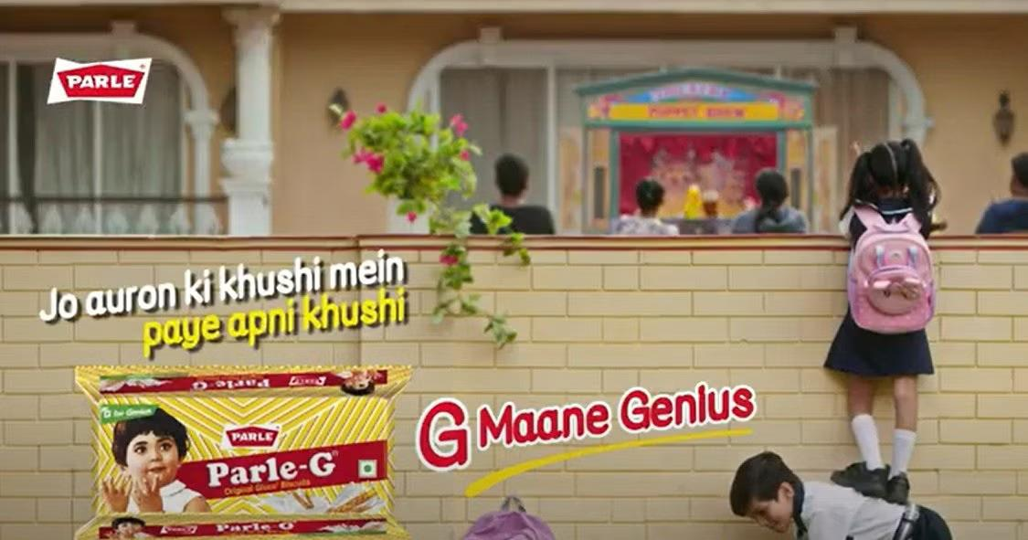
Text translation: They find joy in the happiness of other - G for Genius

- Read the excerpt from the website of St Joseph’s University, Bangalore. Do you think the writing is an effective introduction to university? Attempt a rewrite of the passage that would make it more effective to the target audience.

St Joseph’s University (SJU) is a Jesuit university at the heart of Bengaluru, the Silicon city of India. Established in 1882 by Paris foreign Fathers, the management of the college was handed over to the Jesuit order (Society of Jesus) in 1937. The college was first affiliated to the university of Madras and later to the Mysore and Bangalore universities. In 1986, St Joseph’s College became the first affiliated college in Karnataka to offer postgraduate courses. In 1988, it became the first college in Karnataka to get a research center and in 2005, it was one of five colleges in Karnataka that was awarded academic autonomy. In February 2021, St Joseph's University bill was presented in the Karnataka Legislative Assembly and was subsequently passed by the Legislative Assembly and Karnataka Legislative Council. The college received its University status on 2nd July 2022 and was inaugurated as India’s first public-private university by the President of India, Smt. Droupadi Murmu on 27 September 2022.

- Explain the five steps to be followed for content development? Why is an effective content development strategy important during writing?

PART C

Answer the following questions in about 200-250 words: (1x15=15)

- Make a three leaf brochure for getting first-time voters/people who have just turned 18 to register. The brochure should be a combination of both visual and text based content. Clarity of ideation, design, placement of visuals and choice of text will be assessed. Your ability to draw won’t be marked.

***

