**ST JOSEPH’S UNIVERSITY, BENGALURU -27**

**IV SEMESTER- BA JIN/PP**

**END SEMESTER EXAMINATION: MAY 2024**

**(Examination conducted in May /June 2024)**

**JNI 422– JOURNALISM AND ETHICAL PRACTICE**

**(For current batch students only)**

**Time: 2 Hours Max. Marks: 60**

This paper contains FOUR printed pages and FOUR parts.

**Instructions:**

1. This paper is for IV semester JIN/JPP students.
2. You are allowed to use a dictionary.

**PART-A**

**Read the following excerpt from Sanskriti Talwar’s article “ Migrants in Nanded: no shelter, no water” published on *People’s Archive of Rural India* (*PARI).***

Gangubai Chavan must plead for a share of drinking water. “Sarkar! Watchman *sahib!* Please give us water to drink. I am a resident here, sir.”

But merely pleading is not enough. She has to assure them, “I won’t touch your vessels.”

Gangubai (name changed) depends on water from private taps, tea stalls, and marriage halls. She implores watchmen of buildings like the hotel opposite her ‘home’ on the footpath in Gokulnagar area of Nanded city. And she does this every day, every time she needs water.

Finding water is a daily task, and her search is compounded by the stigma she faces everyday as a member of the Phanse Pardhi tribe, once notified as ‘criminal tribes’. A colonial era nomenclature, it was [repealed](https://ruralindiaonline.org/en/library/resource/report-of-the-national-commission-for-denotified-nomadic-and-semi-nomadic-tribes-idate-commission/#section02) by the Indian government in 1952. Yet, 70 years later, people like Gangubai fight for basic rights; she has to convince others that she is not a thief and only then can she get a drum full of water.

“It is only when we say, ‘we have never touched any of the things you have kept here’, that they give us some water,” says Gangubai. Once permitted, she collects as much water as possible in small containers, plastic drums and water bottles. If one hotel refuses, she tries at the next one, brushing aside the rude owners; she often has to ask at four-five places before someone relents and she gets water to drink, cook and run her home.

Migrants like Gangubai arrive in Nanded from villages and other districts of Maharashtra. “We are here (in Nanded) for eight months, and return to our village once the monsoon starts,” she explains. Families set up homes in temporary shelters on open grounds, footpaths, spaces under overhead water tanks, landfills and railway stations in the city. Their purpose is to secure work for the period they are here and they move as needed.

There is no permanent system to provide access to water to migrant, transhumant groups anywhere in the city. Children, women and especially young girls have to bear insults and violence in their search for water.

Women and girls are the ones largely tasked with water collection, and face the brunt of refusals. But that’s not all. There is always the hustle-bustle of people on the footpath and no provision for public bathing rooms. “We [have to] bathe wearing our clothes. We bathe very quickly. There are so many men all around. We feel shy, people keep watching. We finish bathing quickly, remove our clothes and wash them,” says Samira Jogi. The 35-year-old is from Lucknow and belongs to the Jogi community, classified as OBC in Uttar Pradesh.

“To bathe in the public facilities, we have to pay Rs. 20 each time. For people like us who live hand-to-mouth, how can we afford it?” asks Gangubai. “If we don’t have that much money on us, we skip bathing that day.” Khatun Patel who lives near the railway station says, “If we don’t have money, then we go to the river to bathe. There are a lot of men who hang around there, so it’s tough for us.”

At the time of menstrual periods, the challenges for women increase manifold. Irfana says, “When I menstruate, I have to make an excuse to use the toilet and then change my pad there. On the seventh day, we must have a bath. Then I have to pay 20 rupees to use the public bathroom and bathe.”

Each use of the public toilet costs 10 rupees and for all members of a large family it becomes unaffordable. It’s cheaper to go out in the open. “The public toilet closes after 10 O’ clock in the night. Then we have to go out in the open, what else can we do?” says Ramesh Patode, 50, a resident of the settlement on Municipal grounds.

“We defecate in the open. We feel scared if we have to go in the night, so we take along two-three girls for company,” says Nayana Kale, living on the footpath near the municipal ground in Gokulnagar. “When we are out in the open, the men call out and tease us. Sometimes they even follow us. We must have complained to the police a hundred times”.

In 2011-12, a City Sanitation [Plan](https://smartnet.niua.org/sites/default/files/resources/NIUA-PEARL%20Good%20Practices%20Water%20Supply%20%26%20Sanitation.pdf) was prepared under the Total Sanitation Campaign in Nanded. At that time, around 20 percent of the city population was defecating in the open. In 2014-15, Nanded city had 23 public toilets with just 214 seats, a deficit of more than 4100 seats, says a [report](https://www.teriin.org/sites/default/files/2018-02/2013MC10%20Nanded_ESR_2014-15_2.pdf) . The then Municipal Commissioner Nipun Vinayak implemented a participatory project for improved sanitation, wastewater and waste management under the Community-led Total Sanitation program. In 2021, Waghala Municipal Corporation received the ODF+ and ODF++ (Open Defecation Free) certificates.

However, for the marginalised transhumant communities in the city, drinking water and clean and safe sanitation is still a distant dream as Javed Khan says, “There is no guarantee of getting access to clean, potable water.”

**Answer the following questions in 5-8 sentences each: (3x5=15)**

1. What is your understanding of “marginalised transhumant communities”?
2. Condense the whole excerpt into a 4 slide Instagram post.
3. If you were the editor working on this piece, which idea/aspect from the passage would you pick to convert it into a long-form piece?

**PART-B**

**Answer the following In 100-150 words each: (2x10=20)**

1. The below extract is taken from the *Feminism in India* article “Meet the Women Behind #DalitWomenFight Trying to Take Down ‘Caste Apartheid’” by Rucha Chitnis.

“We met women from Black Lives Matter and learned how they built their campaign. We also met Angela Davis and presented our poster to her and shared about our struggle. It was good to see the sharp perspective of these women. We had an intimate conversation at a home with women from #SayHerName action, which was powerful. We shared our vulnerabilities as oppressed women, and we also saw the strengths of our collectives. We saw so many parallels in our struggles, while recognizing the differences of race and caste. We realized the similarities of the impunity of state violence that denies us justice, dignity and respect. We talked about how brownness in India is also whiteness through Brahmin and upper-caste privilege. We talked about solidarity, how we unpack these questions that are very important to us, and now we have amazing new sisters and allies.”

What is the definition of an ally? Who are the allies of the Dalit Women’s Self-Respect March and why do you think a sense of solidarity exists among them?

1. “Launda Naach (featured in the documentary “Naach Bhikaari Naach” by Jainendra Dost and Shilpi Gulati) is seen as a form of resisting the existing caste and gender norms.”

Do you agree with this statement? Give reasons.

**PART-C**

**Write short notes on the following in TWO-THREE sentences each:**

**(5x2=10)**

1. Bengaluru water crisis 2024
2. Dubai floods
3. Taliban’s suspension of TV stations in Afghanistan
4. Arun Goel’s resignation from the Election Commission
5. Orange Peel Theory
6. Arvind Kejrival’s arrest

**PART-D**

**Draft an Instagram caption for the following cartoon in 150-200 words: (1x15=15)**

12.

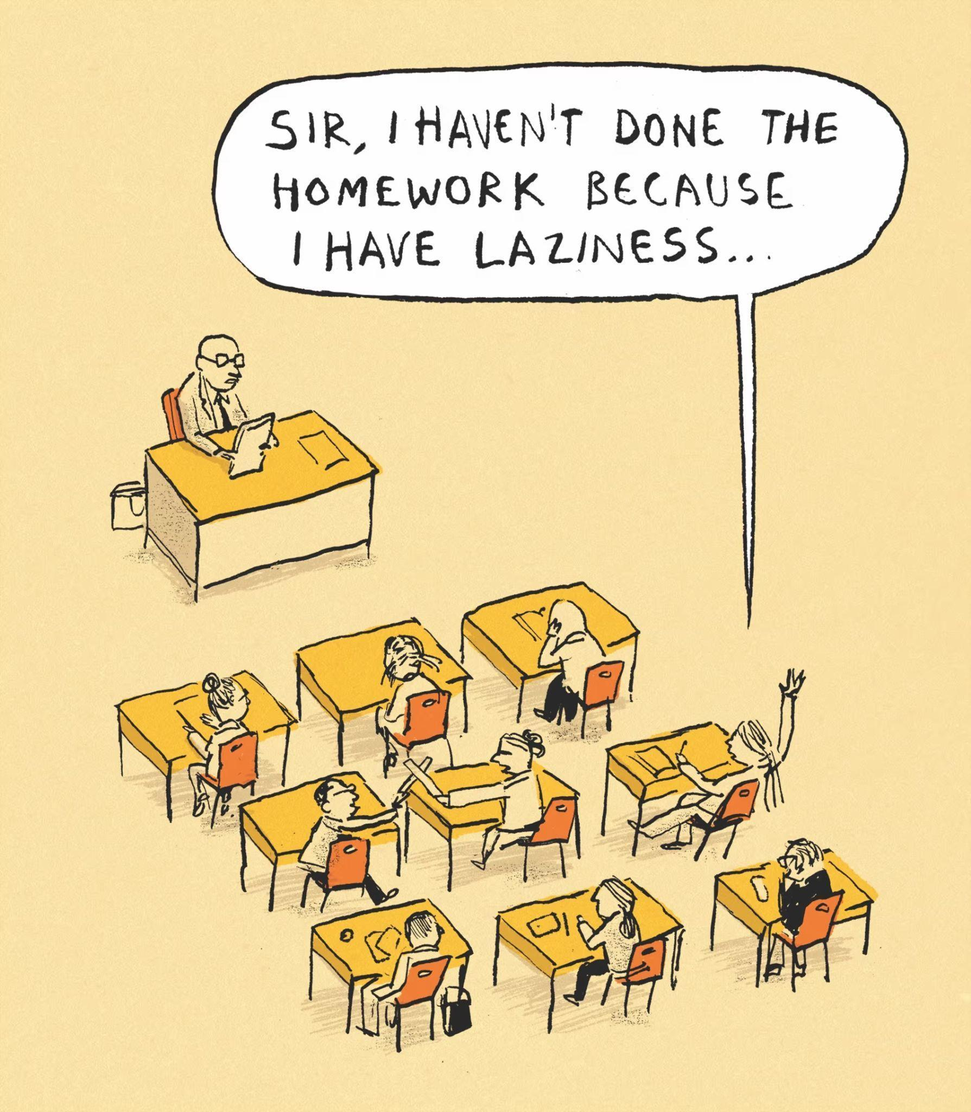

Source: Berger & Wyse on reasons for not doing homework- cartoon, *The Guardian*