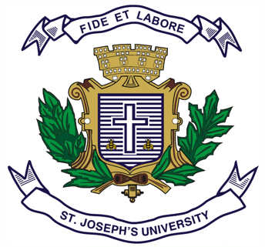
ST JOSEPH’S UNIVERSITY, BENGALURU -27
Registration Number:
Date & session:
MA ADVERTISING AND PUBLIC RELATIONS– 2nd SEMESTER
SEMESTER EXAMINATION: APRIL 2024
(Examination conducted in May / June 2024)
APR 8122: DIGITAL COMMUNICATION
(For current batch students only)

Time: 2 Hours Max Marks: 50
This paper contains ONE printed page and TWO parts

PART A

Answer any five questions in 150 words each. (5x6=30)

- Discuss the role of social media in digital marketing.

- Explain the importance of content marketing in building brand reputation.

- What are the key components of a digital marketing strategy?

- Briefly explain the importance of SEO in digital marketing.

- What are the forms and format of digital advertising? Explain them with examples.

- Evaluate the effectiveness of influencer marketing in the current digital landscape.

- Explain how different buy types like CPM, CPC, CPV and CPA are used in creating a media plan. Showcase with examples.

PART B

Answer any TWO in 250 words each (2x10=20)

- Analyse the influence of social media marketing on enhancing brand recognition and awareness. Elaborate on the various strategies used within social media platforms to build brand visibility.

- Explain the advantages and disadvantages of email marketing. Write down a flow for a drip mailer for any e-commerce brand of your choice.

- Why is audience targeting important? What are the different types of audience that we can target. Explain them in detail.

*****

