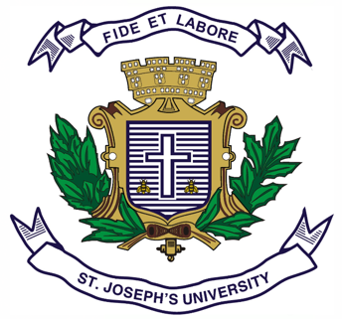
Registration Number:
Date & session:
ST JOSEPH’S UNIVERSITY, BENGALURU -27
MA JOURNALISM AND MASS COMMUNICATION - 2nd SEMESTER
SEMESTER EXAMINATION: APRIL 2024
(Examination conducted in May / June 2024)
MC 8221 - MEDIA LAW AND ETHICS
(For current batch students only)

Time: 2 Hours Max Marks: 50
This paper contains TWO printed pages and TWO parts

PART A

Answer any FIVE of the following in 150 words each. (5X6=30)
- What are the main objectives and goals outlined by Directive Principles? How do they guide the state in its policies and actions?
- What do mean by sting operations? Provide suitable example of a successful sting operation conducted by Indian journalist/s.
- Outline five differences between law and ethics.
- Explain briefly the recommendations of First and Second Press Commission.
- What is Digital Personal Data Protection (DPDP) Act, 2023? Discuss briefly its importance in the context of data protection and privacy.
- What is contempt of court? Explain its different types with the help of suitable case studies.
- What are Intellectual Property Rights (IPRs)? Explain briefly any two types of IPRs with appropriate example for each.

PART B
Answer any TWO of the following in 350- 400 words each. (2X10=20)
- Explain defamation and its various types using case studies. Discuss in detail the defenses available to the media practitioners in combating defamation accusations.
- Write a note on the following in 90 -100 words each.
- Article 19 (1) (a)
- Working Journalists and Other Newspaper Employees (Conditions of Service) and Miscellaneous Provisions Act, 1955.
- Cyber crime and its types
- RTI Act 2005
- What is self-regulation in media? Explain in detail the history, organizational structure, and functions of Press Council of India (PCI). Enumerate the code of conduct issued by the PCI for journalists.

*****************

