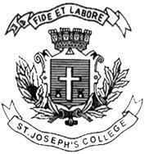
ST JOSEPH’S UNIVERSITY, BENGALURU -27
Registration Number:
Date & Session
B.A. Visual Communication– 4th SEMESTER
SEMESTER EXAMINATION: April 2024
(Examination conducted in May / June 2024)
VC 4222 – SOUND DESIGN FOR VISUAL MEDIA

(For current batch students only)
Time: 2 Hours Max Marks: 60
This paper contains ONE printed page and THREE parts

PART-A

Write short notes on any FIVE in not less than 150 words (5x5=25)

- Portable sound recorder
- WAV
- Condenser microphone
- Wavelength of sound
- Sample rate
- Dolby Atmos
- Phantom power.

PART-B

Answer any TWO in not less than 300 words (2x10=20)

- What is a mixing console? Mention any two uses of the same.
- With the help of an example please explain the significance of film scoring.
- Explain the responsibilities of a production sound mixer.

PART-C

Answer any ONE in not less than 400 words (1x15=15)

- With the help of diagrams elucidate the polar pickup patterns of microphones.
- Explain the process of the first sound draft (sound map) preparation for a feature film.

