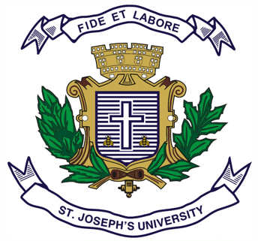
Registration Number:
Date & session:
Registration Number:
Date & session:

ST JOSEPH’S UNIVERSITY, BENGALURU -27
B.S.W – 2nd SEMESTER
SEMESTER EXAMINATION: APRIL 2024
(Examination conducted in May / June 2024)
SWOE 2321: Social Work Concerns for Women and Children

(For current batch students only)

Time: 2 Hours Max Marks: 60
This paper contains one printed page and two parts

PART-A
Answer any four of the following 4 x 10 = 40
- There is a difference between sex and gender. Comment.
- Describe gender stereotypes with an examples.
- What is the impact of divorce on women?
- Highlight the salient features of the Widow Remarriage Act, 1856.
- Explain the functions of the National Commission for Women.

PART-B
Answer any two of the following 2 x 10 = 20
- Enumerate the functions of ICDS and ICPS.
- Highlight the provisions adopted in the United Nations Convention of the Rights of the Child.
- “Balaji (age11) is forced to work in a brick kiln at the outskirts of Bengaluru. He was taken as a bonded labourer when he was 8 years old. For the past three years, his parents haven’t seen him and his condition in the worksite is pitiable”.
You are approached by someone to help rescue Balaji. Create your intervention plans keeping in mind specific acts and policies that you’ve studied in this course.

