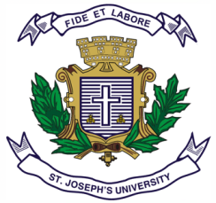
ST JOSEPH’S UNIVERSITY, BENGALURU -27
Registration Number:
Date & Session
B.S.W – 4th SEMESTER
SEMESTER EXAMINATION: April 2024
(Examination conducted in May / June 2024)
SWOE 4322 – DISASTER MANAGEMENT

(For current batch students only)
Time: 2 Hours Max Marks: 60

This paper contains one printed page and two parts

PART-A
Answer any four of the following 4 x 10 = 40
- Describe any two natural disasters with examples.
- Describe any two man-made disasters with examples.
- Explain the social impact of disasters with a suitable example.
- Highlight the features of the National Policy on Disaster Management.
- What are the do’s and don’ts during a disaster?

PART-B
Answer any two of the following 2 x 10 = 20
- Describe the process in disaster risk management with suitable example.
- Detail the Disaster Management Cycle with suitable examples.
- Two hundred households in a village were swept away due to flood. Close to 15 families lost their dear ones and one hundred and twenty six families incurred severe property loss. What would be the possible psycho-social intervention to be provided to the community? Explain with example.

