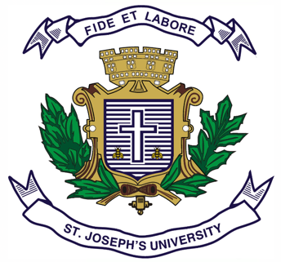
Registration Number:
Date & session:

ST JOSEPH’S UNIVERSITY, BENGALURU -27
B.S.W– 6th SEMESTER
SEMESTER EXAMINATION: APRIL 2024

(Examination conducted in May /June 2024)

SW 6222: Mental Health and Social Work

(For current batch students only)

Time: 2 Hours Max Marks: 60
This paper contains TWO printed pages and THREE parts

PART-A
Answer any FIVE of the following 5 x 2 = 10
- Define mental health.
- What is CBR?
- Mention any two developmental disorders.
- Outline four symptoms commonly associated with psychosis.
- Expand: (a) ICD (b) DSM
- Enumerate any two common symptoms of depression.
- Give two examples of psychosis.

PART-B
Answer any FOUR of the following 4 x 5 = 20
- Briefly explain how have attitudes and beliefs regarding mental illness evolved in India.
- Discuss the role of social workers in community mental health settings
- Explain the role of social workers in identifying and supporting individuals at the risk of suicide.
- How do psychiatric disorders impact an individual's daily functioning and quality of life?
- Write a note on Organic Mental Disorders
- Write a short note Substance Abuse Disorder.

PART-C
Answer any TWO of the following 2 x 15 = 30
- Discuss the mental health challenges faced by Persons With Disabilities (PWDs). Explain the role of social workers in providing support to them.
- How do NGOs, voluntary organizations, and community action groups contribute to mental health advocacy and social action? Explain.
- Discuss the importance of multidisciplinary teams in mental health care settings and describe how social workers collaborate with other professionals to provide comprehensive care.

