Registration Number:
Date & Session

ST JOSEPH’S UNIVERSITY, BENGALURU -27
B.Sc. ELECTRONICS - 4th SEMESTER
SEMESTER EXAMINATION: April 2024
(Examination conducted in May / June 2024)
EL421 – DATA ACQUISITION AND INSTRUMENTATION
(For current batch students only)
Time: 2 Hours Max Marks: 60
This paper contains three printed pages and three parts

Part A
Choose the correct answer 10 X 1 = 10

- A measuring instrument gives same measurement for a given input many number of times. We can conclude that the instrument has
a) Good accuracy b) Good precision
c) Good accuracy and poor precision d) poor accuracy and good precision.
- A photovoltaic cell act as a photo conductive cell under the following condition.
a) forward biased b) reverse biased c) when light falls on it d) unbiased
- Step size of a 4 bit DAC is 0.6 V, then the full scale output is
a) 2.4 V b ) 9.6 V c) 9 V d) 4.2 V
- Circuit which can produce a ramp voltage is
a) Integrator b) differentiator c) Astable multivibrator d) rectifier
- In a 3 and half digit DMM, the maximum voltage that can be measured in 10 V range is
a) 10 V b) 9.99 V c) 99.9 V d) 19.99 V
- For frequency measurement in a CRO, input signal is applied across
a) vertical deflecting plate
b) horizontal deflecting plate
c) any of the deflecting plates
d) VDP for voltage and HDP for frequency measurement
- In a frequency counter, clock input to the gate is of frequency 10 Hz. If the counter counts 600, what is the frequency of input signal?
a) 600 Hz b) 6000 Hz c) 60 Hz d) 60 KHz
- In an LCD, light is produced by
a) liquid crystal b) external source c) polaroid d) electric field
- Which of the following projector creates an image using digital micro mirror device as rear projection TV?
a) front b) LCD rear c) reflective d) DLP
- How many segments must be lighted to display number 4 in a 7 segment LED display?
a) 3 b) 5 c) 4 d) 6

Part B
Answer any 5 questions: 5 X 6 = 30

- a) Differentiate between active and passive transducers.
b) Explain the principle , construction and working of a thermistor?
(2 + 4)

- a) What is a thermocouple? Mention its application.
b) Explain the three types of photoelectric transducers. (2+4)
- Draw block diagram of a flash ADC and explain its working. Mention one advantage of Flash ADC over SAR ADC?

- a) Draw the block diagram of a dual slope integrating type DVM and explain its working principle.
b) Draw block diagram of a frequency meter. (4+2)
- a) Draw the block diagram of a signal generator and explain its working.
b) Differentiate between resolution and sensitivity of a digital voltmeter.
(4+2)
- a) Draw the block diagram of a CRO and explain the function of each block.
b) What are lissajous figures in a CRO?
(4+2)
- a) Explain the working of LCD as a display device.
b) Explain the working of DLP.
(3+3)
Part-C
Answer any 5 of the following: 5 x 4 = 20
- A variable reluctance type inductive transducer has a coil of inductance 1800 µH when the target made of ferromagnetic material is 1 mm away from the core. Calculate the value of inductance when the target is displaced 0.4 mm towards the core.

- In the followig setup of strain measurement, Vin = 12V, R1= R2 = R3 = R_{G} = 100Ω before applying strain. When strain is applied, the voltmeter reads 1V. The gauge factor is 2. Calculate the strain applied.
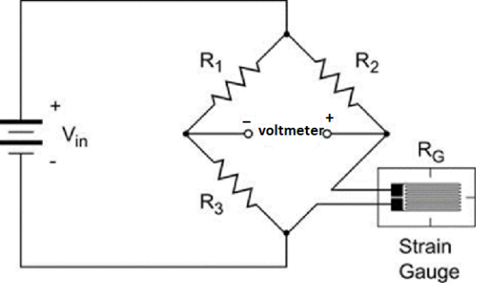
- A four bit binary weighted resistor DAC is constructed using op-amp in inverting mode. It has a reference input of 5 V. Calculate step size, resolution, % resolution and full scale output if the minimum value of weighted resistor is 1 K and R_{f} = 1 K.

- A dual slope digital voltmeter has a positive integrator of resistance 220 kΩ and capacitance 1 µF. If the input d.c. voltage is 1 V, what would be the output of the integrator after 1 Second? If a reverse voltage reduces the output to zero in 0.2 seconds, what is the value of the reverse voltage?

- In a capacitance meter, an astable multivibrator using ic555 is used before the frequency counter. R_{A} = 2.2 kΩ, R_{B} = 5.6 kΩ and the counter counts 180 during discharge of capacitor (OFF time). The frequency of the clock gate pulse is 100 KHz. Calculate the value of unknown capacitance.

- A 4 ¹/₂ digit voltmeter is used for voltage measurements:
(i) Calculate its resolution at 1 V FSD
(ii) How would 6.78 V be displayed in 10 V range?
(iii) How would 0.7526 V be displayed on 1 V range and 100 V range?

- In the instrumentation amplifier circuit given below, R = 10 KΩ, R_{GAIN} = 5.6 KΩ. Calculate the output voltage if V₁ = 2 V and V₂ = 1.6 V, V_{CC}=12 V, V_{EE} = -12 V for all op-amps.
.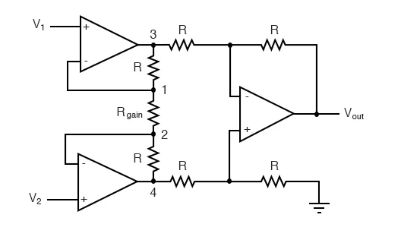

xxxxxxxxxxxxxxxxxxxxxxx

