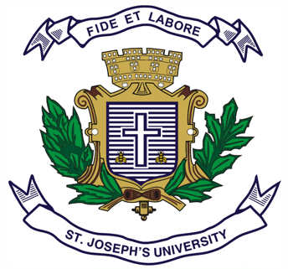
Registration Number:
Date & session:
Registration Number:
Date & session:

ST JOSEPH’S UNIVERSITY, BENGALURU -27
B.VOC.VISUAL MEDIA AND FILMMAKING – 2nd SEMESTER
SEMESTER EXAMINATION: APRIL 2024
(Examination conducted in May / June 2024)
VOF 2123: WORLD CINEMA

(For current batch students only)

Time: 2 Hours Max Marks: 60
This paper contains ONE printed page and THREE parts

PART-A

Write short notes on any FIVE in not less than 150 words (5 x 5 = 25)
- Cabinet of Dr. Caligari (1920)
- Japanese New wave
- The Hollywood studio system
- Kinetoscope
- British New wave
- Persona(1966)
- Mumblecore
PART-B

Answer any TWO in not less than 250 words (2 x 10 = 20)
- What is French new wave cinema? Mention any two filmmakers from the same.
- Elucidate Dogme 95 film movement with the help of an example.
- Enzo Staiola’s portrayal of Bruno Ricci in Bicycle thieves, is arguably the best performance by a child artist in a feature film. Discuss.

PART-C

Answer any ONE in not less than 350 words (1 x 15 = 15)
- Write brief notes in about 180 words each.
- German Expressionism
- Soviet Montage
- What is queer cinema? What are its defining characteristics?

