Register Number:
DATE and Session :
ST.JOSEPH’S UNIVERSITY, BANGALORE-27
B.Sc. ELECTRONICS – I SEMESTER
SEMESTER EXAMINATION- OCTOBER 2023
(Examination conducted in November/December 2023)
EL 123- BASIC ELECTRONICS

(For current batch students only)

Time: 2 hrs Max marks: 60

This paper contains THREE printed pages and THREE parts

PART- A
Choose the correct answer: 10x1=10
1. Application of Norton’s theorem to a circuit yields _____________.
A. equivalent current source and impedance in series
B. equivalent current source and impedance in parallel
C. equivalent voltage source and impedance in series
D. equivalent voltage source and impedance in parallel

2. _______ is defined as an opposition to the flow of current in a circuit due to its
capacitance, inductance and resistance.
A. resistance B. reactance C. impedance D. conductance
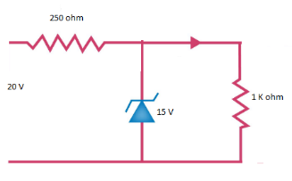
3. A Zener diode, having breakdown voltage equal to 15 V, is
used in a voltage regulator circuit shown in the figure. The
current through the diode is __________.
A. 10 mA
B. 15 mA
C. 20 mA
D. 5mA
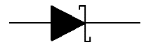
4. The symbol represents _____________ diode.
A. Tunnel B. Zener C. Varactor D. Schottky

5. The relationship between α and β of a transistor is _____.

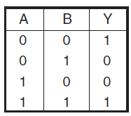
6. The output Y observed is for ____gate.
A. AND
B. OR
C. XOR
D. XNOR

7. Identify the fixed bias with emitter resistor circuit. 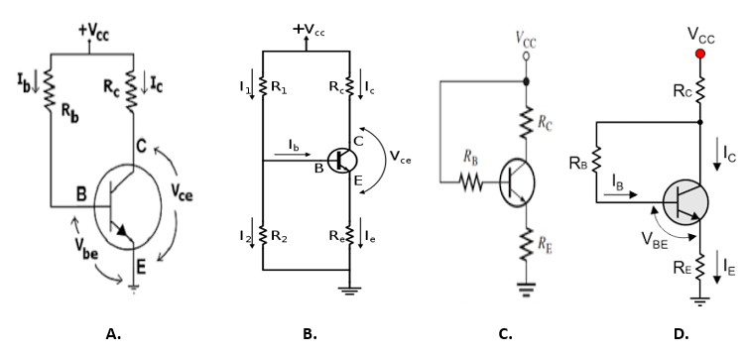

8.The next number in the count sequence of FFF9H is ________.
A. 0000H B. FFFFH C. 0010H D. FFFAH

9. The simplified expression for: (X + Z)(X + XZ’) + XY + Y is ________.
A. XY+Z’ B. Y+XZ’+Y’Z C. X’Z+Y D. X+Y

10. The voltage gain of CC amplifier is _______.
A. <1 B. >1 but <2 C. >100 D. ∞
PART- B

Answer any five questions: 5x6=30

11a) State and explain maximum power transfer theorem.
b) Draw the graphical response during its charging process of a capacitor in a dc series
RC circuit and define its time constant. (4+2)

12a) Arrive at the resonant frequency of a series RLC circuit and explain its impedance
Curve.
b) Draw the circuit of a biased negative clipper and draw its output waveform. (4+2)

13a) With the help of a CTFWR circuit explain its working and give the expression for its dc
output voltage.
b) Write a voltage tripler circuit and explain. (4+2)

14a) Draw a CE amplifier circuit and write the expression for voltage gain and input
impedance.
b) Define stability factor for a transistor and state its importance. (4+2)

15a) Draw transistor output characteristics in CB mode, mention the regions and steps to
obtain α of the transistor.
b) What is a BCD code? What are its limitations? (4+2)

16a) Mention the steps of converting a Gray code number to a binary number with the help
of an example
. b) Write circuit of two input diode AND gate and write its truth table. (4+2)

17a) State and prove De Morgan’s laws.
b) Verify the universality of NOR gate by providing suitable examples. (4+2)

PART- C
Answer any five questions: 5x4=20

18. Determine the current in 10Ω resistor using superpostion theorem.
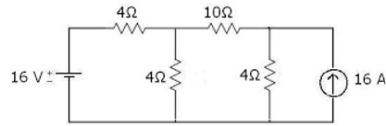

19. A coil which has an inductance of 40mH and a resistance of 2Ω is connected together to
form a LR series circuit. If they are connected to a 20V DC supply,
a) What will be the final steady state value of the current
b) What will be the time constant of the RL series circuit
c) What will be the value of the induced emf after 10ms
d) What will be the value of the circuit current in one time constant after the switch is
closed.

20. The turn's ratio of the transformer used in a Bridge rectifier is 10:1. The primary is
connected to 220V, 50 Hz power mains. Find the output DC voltage, ac ripple voltage,
PIV of diode and ripple frequency when R_{L}=1KΩ and r_{d}=10Ω.

21. Draw the output waveform for the circuits given below:
i) ii)
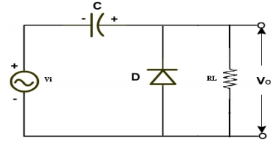
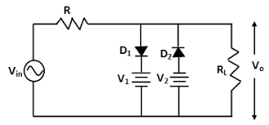

22. For the circuit shown in figure. Calculate I_{CQ} and V_{CEQ}. Assume V_{BE}= 0.7V and β=150.
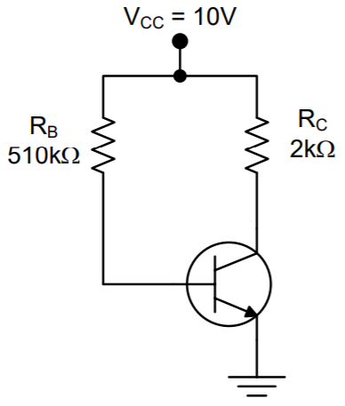

23. i) add -68H and 97H using 2’s complement method.
ii) add 52H and 78H using BCD arithmetic.

24. i) Write the output X for the following digital circuit.
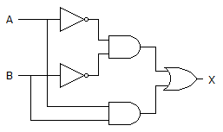
ii) Simplify the Boolean expression: Y=A(A+B’C)+A(B’+C)

-------------------------------------------------------

