Registration Number:
Date & session:
Registration Number:
Date & session:

ST JOSEPH’S UNIVERSITY, BENGALURU -27
BCA – 2nd SEMESTER
SEMESTER EXAMINATION: APRIL 2024
(Examination conducted in May / June 2024)
CA 2121: Data Structures Using C
(For current batch students only)
Time: 2 Hours Max Marks: 60
This paper contains TWO printed pages and THREE parts

PART A
Answer any five of the following questions (2*5=10)
1. What do you mean by Data Structures? With examples show how linear data structures differ from non-linear data structures.
2. Write a function subprogram in C to return 1 if the stack is empty or else return 0.
3. Explain the meaning of Big-O notation to assess the complexity of an algorithm.
4. Given the following list of numbers create a BINARY SEARCH TREE.
65, 83, 20, 30, 12, 80, 60, 90, 69,15, 27, 62
5. Write a function subprogram in C to display the contents of a linked list.
6. Write a function subprogram to remove an element from a circular queue.
PART B
Answer any five of the following questions (4*5=20)
7. Write a program in C to input some numbers into an array and sort them using INSERTION SORT technique.
8. Using a STACK show the conversion of the following INFIX expressions into POSTFIX expression.
A + ((C – D *E)*F) /( G - H)^2
9. Given the recurrence formula below, calculate the complexity of the algorithm represented by the recurrence formula.
T(n) = T(N-1) + 1 for n>0
T(0) = 1
10. Write a function subprogram in C using a stack to convert a decimal number into its BINARY EQUIVALENT.
11. What is a SPARSE MATRIX? With an example show how it can be implemented using a linked list.
12. Given the precedence of operators [ “(“ :1, “)”2, +,-:3, *,/: 4, ^: 5 ] .Write a function sub program to return the precedence of a given operator.
13. Give an algorithm to insert a node into an ordered DOUBLY LINKED LIST.

PART C
Answer any three of the following questions (3*10=30)
14. a. Given the PREORDER TRAVERSAL of a binary search tree, create the binary search tree. Show the steps involved.
E, C, A, B , D, H, F, G, I
b. Declare a data type to represent node of a Queue. Write a function Dequeue() to delete a number from the Queue ( Front and Rear are global pointers representing the beginning and the end of the queue )
[4+6]
15. a. Write a program in C to evaluate a postfix expression.
b. With the help of a tabular column show how the following postfix expression is evaluated using a stack.
5, 10, 5, -, 2, ^, 8, 3, -, 2, *, /, + [7+3]
16. a. Write the preorder traversal for the following tree
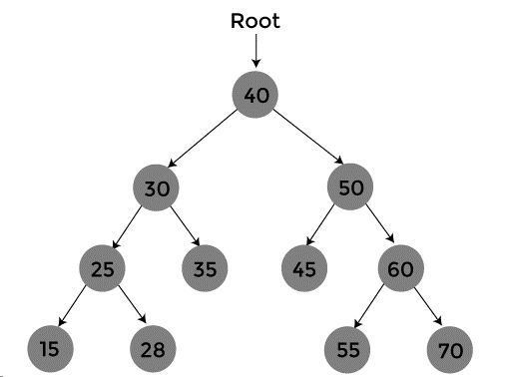
b. Create a new data type to represent the node of a BST known as TREENODE having integer data item and two links to right and left sub trees. Write function subprograms to insert a number into the BST, and recursive functions to do INORDER traversal.
[4+6]
17.a. Construct a tree from the given traversals
Inorder Traversal: D,B,A,G,E,H,C,F
Preorder Traversal: A,B,D,C,E,G,H,F

b. Write a function program to search for a given number using BINARY search. Let it return 1 if the number is found or else return 0. What is the condition for using binary search? Which searching method is efficient? Linear or Binary? Why? [5+5]

****************************************************************************************************

