Register Number:
Date:
ST JOSEPH’S UNIVERSITY, BENGALURU -27
B.C.A – 2nd SEMESTER
SEMESTER EXAMINATION: APRIL 2024
(Examination conducted in May / June 2024)
CA2321– Discrete Mathematical Structures
This paper contains FOUR printed pages and three parts
Time – 2 hours Max Marks-60
Part A
I Answer all the following 2*5=10 Marks
- If the proposition ¬ p ⇒ q is true, then the truth value of the proposition ¬ p ∨ (p ⇒ q), where ¬ is negation, ‘∨’ is inclusive or and ‘⇒’ is the implication, is
(a) True
(b) Multiple valued
(c) False
(d) Cannot be determined
Justify your answer by solving.
- In how many of the distinct permutations of the letters in MISSISSIPPI do the four Is not come together?
- Write an algorithm to implement Linear Search.
- If A = {1, 2, 3, 4} R and S are the two relation on A defined by R = {(1,2) (1,3) (2,4) (4,4)} S= {(1,1) (1,2)(1,3) (2,3) (2,4)} ; Find So(RoS) and (RoS)oR
- Construct a Fundamental Circuit from the following Graph.
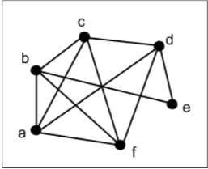

Part B
II Answer Any five of the following 4*5=20 marks
- Translate the following statement into English. 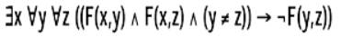
F(x, y) : x and y are friends.
Domain of x, y and z: all students
- I have 7pairs of socks in my drawer, one of each color of the rainbow. How many socks do I have to draw out in order to guarantee that I have grabbed at least one pair? What if there are likewise colored pairs of gloves in there and I cannot tell the difference between gloves and socks and I want a matching set? (You may use pigeonhole principle)
- Solve the recurrence relation an+2 + an =0, n ≥ 0, a₀ = 0, a1 =3 .
- Solve (2x-3y) ²⁵ using Binomial Coefficient.
- Find the shortest paths between ‘b’ and ‘i’ in the graph shown in fig using Dijkstra's Algorithm. Write the detail steps.
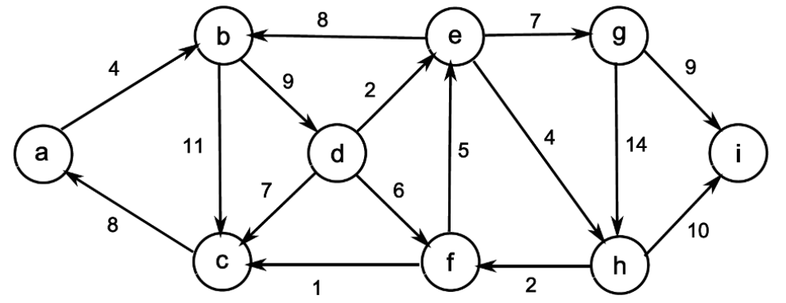
- Show that the following two graphs are isomorphic by labelling the vertices of right-hand graph appropriately.
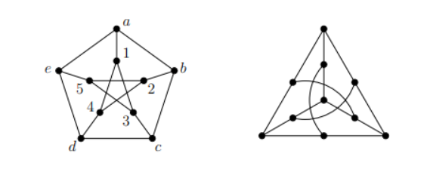

- Using the principle of Mathematical Induction, Prove that
1 ∙ 2 + 2 ∙ 3 + 3 ∙ 4 + ......................... + n(n + 1) = (1/3){n(n + 1)(n + 2)}.
- Let’s consider a propositional language where
•A=“Angelo comes to the party”,
•B=“Bruno comes to the party”,
•C=“Carlo comes to the party”,
•D=“Davide comes to the party”.
Formalize the following sentences:
1. “Angelo comes to the party while Bruno doesn’t”
2. “Either Carlo comes to the party, or Bruno and Davide don’t come”
3. “If Angelo and Bruno come to the party, then Carlo comes provided that Davide doesn’t come”
4. “Carlo comes to the party if Bruno and Angelo don’t come, or if Davide comes”
5. “If Angelo comes to the party then Bruno or Carlo come too, but if Angelo doesn’t come to the party, then Carlo and Davide come
Part C
III Answer any three of the following 10*3=30 Marks
14. a) Use logical equivalences and the rules of inference to determine whether the following argument is valid. (5)
¬(¬p∨q)
¬z→¬s
(p∧¬q)→s
¬z ∨ r
_____
∴ r
b) Arrange the letter of the word “DATAFLAIR” alphabetically using the merge sort technique. (5)
15. a) let a be the sequence defined by a₁ = 1, a₂ = 8 and a _{n} = a _{n - 1} + 2a _{n-2} for n≥3. Prove that using strong induction method a_{n} = 3. 2 ^{n-1} +2(-1)^{n} ∀ n ∈ N. (8)
b) list the difference between Mathematical Induction and Strong Induction. (2)
16. a.
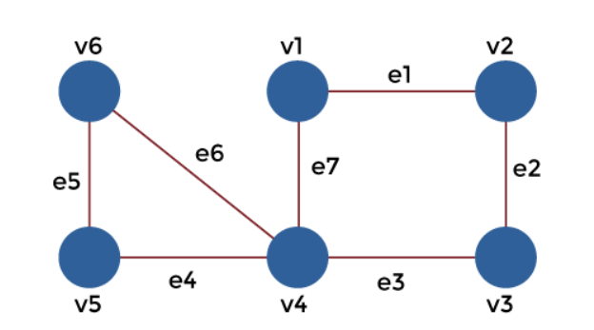
With the help of below sequences, we have to determine the nature of walk in each case: (5)
- v1, e1, v2, e2, v3, e2, v2
- v4, e7, v1, e1, v2, e2, v3, e3, v4, e4, v5
- v1, e1, v2, e2, v3, e3, v4, e4, v5
- v1, e1, v2, e2, v3, e3, v4, e7, v1
- v6, e5, v5, e4, v4, e3, v3, e2, v2, e1, v1, e7, v4, e6, v6
b. Solve Travelling Salesman Problem from the following graph. (5)
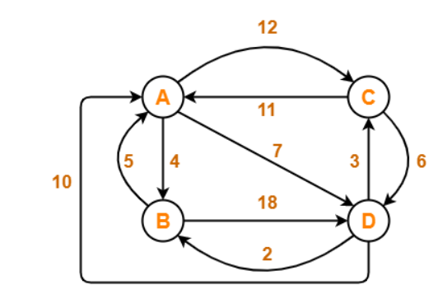

17. a. How many words can be formed by using the letters from the word “DRIVER” such that all the vowels are never together? (2)
b. Assume that 10 cars are in a race. In how many ways can three cars finish in first, second and third place? The order in which the cars finish is important. Use the multiplication principle. There are 10 possible cars to finish first. Once a car has finished first, there are nine cars to finish second. After the second car is finished, any of the eight remaining cars can finish third. Ten students are participating a race. In how many ways can the first 3 prizes be won? (2)
c. How many numbers below 100 are divisible by 2, 3, or 5? Using Principle of Inclusion and Exclusion. (3)
d. Differentiate between Reflexive, Transitive and Symmetric closures of relations. (3)

