Registration Number:
Date & Session

ST. JOSEPH’S UNIVERSITY BENGALURU -27
BCA –IV SEMESTER
END SEMESTER EXAMINATION APRIL-2024
(Examination conducted in May/June 2024)
CA4322: OPERATING SYSTEM CONCEPTS
(for current batch students only)

Time: 2.0 Hours Max Marks: 60

This paper contains 3 printed pages and 3 parts.

PART-A
Answer the following questions (2 X 5 = 10)

- In a batch processing system, describe the role and function of spooling. Provide two key advantages of using spooling in this context.
- Define the terms
a. Shell
b. kernel
3. Define the concept of Deadlocks in process management.
4. What are the primary objectives of memory management in an operating system? Provide a brief explanation of one key strategy used to achieve these objectives.
5. Name the extension type of the files mentioned below:
a. FILE.OBJ
b. FILE.DAT
c.FILE.EXE
d.ABC.XLS
PART- B

Answer any FIVE of the following questions (4 X 5 = 20)

6. Discuss the components and significance of a Process Control Block (PCB) in operating systems. Provide a detailed explanation of three essential pieces of information typically stored within a PCB and how they contribute to process management and system performance.
7. Describe the concept of paging in memory management. Explain the role of page tables in the paging mechanism and discuss how paging helps in overcoming external fragmentation.
8. For the following resource allocation graph draw a wait for graph and identify if a deadlock occurs
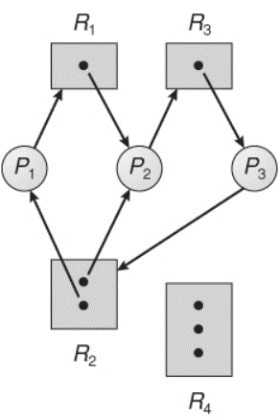
9. Describe the concept of directory structures in file systems. Explain two common types of directory structures, highlighting their differences and advantages.
10. Based on general structure of a typical process Pi given below, write a note on critical section problem of
a) Mutual Exclusion
b) progress
c)bounded wait
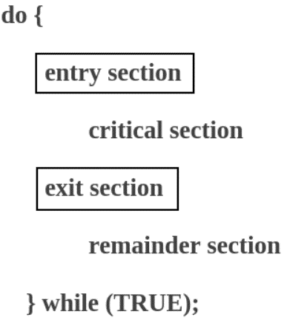

11. Deliberate on the role and importance of system calls in operating systems. Explain four categories of system calls, providing examples for each category.
12. Write a note on operating system as:
a) guardian accountant
b) resource manager
PART C
Answer any THREE of the following questions 10x3=30
13. Based on the table below calculate the average waiting time for
a) First Come First Serve algorithm
b) Priority scheduling algorithm
with an explanation for each of these algorithms.
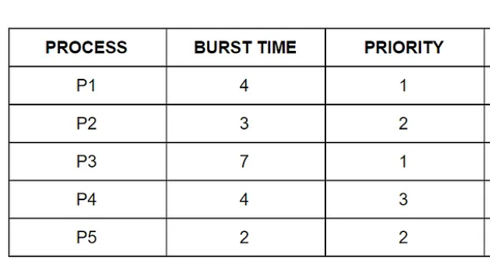

14. Explain the FIFO (First-In, First-Out) and LRU (Least Recently Used) page replacement algorithms with examples. Illustrate how each algorithm selects pages for replacement and discuss their impact on system performance with an example each.

15. Explain demand paging in virtual memory, including its benefits, and drawbacks. Provide practical examples to illustrate the concept of demand paging .
16. Consider the following read/write head movements given below:
a) Calculate the total head movement using the FCFS algorithm
b) Explain the FCFS algorithm in detail



