Register Number:
Date&Session:

ST. JOSEPH’S UNIUVERSITY, BANGALORE-27
MSc Computer Science–II SEMESTER
SEMESTER EXAMINATION: APRIL 2024
(Examination conducted in May/June 2024)
CS8121- Advanced Database management System
(For current batch students only)

Time- 2 hrs |  |  | Max Marks-50
This paper contains two printed pages and three parts

PART A
Answer All the following questions. 5 * 2=10
- Write the purpose of GROUP BY clause of SQL.
- Give any one conflict that can be caused during write and read operation with example.
- Differentiate intra and inter query processing.
- How would you differentiate between OLTP and Data Warehousing in a tabular manner?
- List the Components of Data warehouse.

PART B

Answer any FIVE of the following: 5 *4 =20
- A set of functional dependency for the relation R{A,B,C,0,E,F} is AB->C,C->A, BC->D,ACD->B,BE->C,EC->FA,CF->BD,D->E. Find the minimum cover for this set of FDs.
- Explain timestamp based protocol in concurrent transactions.
- Discuss fragmentation transparency, replication transparency and location
transparency in distributed databases.
- List two major difficulties with the log based recovery without checkpoints.
- Describe the different types of OLAP operations.
- Write the different tools for Data warehouse development.
- Differentiate super key and foreign key with example that is used in company
Database.
PART C

Answer any TWO of the following. 10x2=20
- Give example with reason: i) Serializability ii) Defered (5+5)
14. a) How is “Snowflake Schema” used in Data warehousing? (5+5)
b) Discuss fragmentation transparency, replication transparency and location transparency in distributed databases.
- Consider the following two tables:

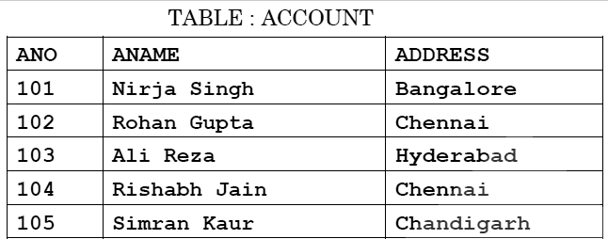
TABLE: TRANSACT

TRNO | ANO | AMOUNT | TYPE | DOT
T001 | 101 | 2500 | Withdraw | 2017-12-21
T001 | 103 | 3000 | deposit | 2017-06-01
T001 | 102 | 2000 | Withdraw | 2017-05-12
T001 | 103 | 1000 | deposit | 2017-10-22
T001 | 102 | 12000 | deposit | 2017-
Use Suitable SQL commands to create above Database with all constraints.

Write the SQL queries for the following:

- To display details of all transactions of TYPE Withdraw from TRANSACT table
- To display ANO and AMOUNT of all Deposit and Withdrawals done in month of
„May‟ 2017 from table TRANSACT
- To display first date of transaction (DOT) from table TRANSACT for Account having ANO as 102
- To display ANO, ANAME, AMOUNT and DOT of those persons from ACCOUNT and TRANSACT table who have done transaction less than or equal to 3000
- SELECT ANO, ANAME FROM ACCOUNT
WHERE ADDRESS NOT IN ('CHENNAI', 'BANGALORE');

