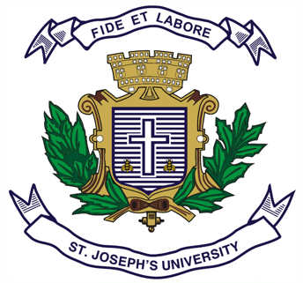
Registration Number:
Date & session:
ST.JOSEPH’S UNIVERSITY, BENGALURU -27
MA ENGLISH – IV SEMESTER
END-SEMESTER EXAMINATION: APRIL 2024
(Examination conducted in November / December 2023)
EN 0118: British Literature IV

(For current batch students only)

Time: 2 Hours Max Marks: 50
This paper contains FOUR printed pages and FOUR parts

INSTRUCTIONS
1. Please stick to the suggested word limit.
2. Do not copy from the passage.
3. You are allowed to use a dictionary during the examination.
PART-A

I.A. Answer ANY ONE of the following questions in 200 – 250 words each:
(1X15=15 marks)
- What arrivals and departures become possible when we look beyond literary modernism to experiments in the visual arts? Does the European, metropolitan nature of the phenomenon become more visible when we extend our study thus?

- Examine the model of British multiculturalism contained in the Blair-era phrase Cool Britannia. Which texts from your syllabus or beyond offer the chance of reading this vision critically?

PART-B

I.B. Answer the following questions in 150 words each:
(2x10=20 marks)

- What are the paradoxes that animate Hopkins’ use of the curtal sonnet form in poems like Pied Beauty?What do they lead the reader to?
- Examine the experiments with form that Virginia Woolf offers in writing A Room of One’s Own. Would you agree with the view that the reader’s imagination is enlisted into exploring the idea of contesting patriarchy through these experiments? Give evidence to support your answer.

PART-C

I.C. Answer ANY ONE of the following questions in 5 – 8 lines each:
(1x5=5 marks)

- Comment on the writer’s choice of images in the following lines:
.The yellow smoke that rubs its muzzle on the window-panes,
Licked its tongue into the corners of the evening,

- What moment of arrival are we offered in this excerpt?
Around us are Rovers and Austins afar,
Above us the intimate roof of the car,

PART-D

D. Read this poem by Daljit Nagra, titled The 13 O’Clock News”:

Pip Pip, today’s feature for Monarchy Month is the first
Indian knighted, in 1842. His name is Sahib Jamsetjee
Jeejeebhoy. But why was a Queen keen to knight a native?

The answer lies with the man in a red ‘phone-box’,
the Arch Liberator, the Truth-Sleuth, you know him
as every lady’s Tonk-Honker: Johhhn Simpsonian!!!

O John Simpsonian, do you ZoomBoom for us?
Pip Pip . . . our connection is scrambling . . . I’ll be brief . . .
This self-made good chap had a chequered mid-life . . .

It seems that in Opium Wartime Jeejeebhoy ran
the speediest clippers bound for China . . . As you see,
I’ve landed at the port . . . at the Yangtze gorge . . .

Those hordes of mango wood boxes are Jamsetjee’s . . .
And the men with machetes are unloading each box
with brown balls inside as big as a comely lady’s breast . . .

O John Simpsonian, through gyres and galaxies,
you’re the boldest ZoomBoomer! If I may sum up,
in this dim droopy night . . . the love-sick mass of men

lined along the bank . . . as though a whole nation
of John Chinamen and Shangrilanders sleepwalking
for a toke, a cut, a suck of the dream of empire . . .

I.D. Answer the following question in 100 – 150 words each: (1x10=10 marks)

- Is playfulness useful while dealing with history?Does the poem illustrate the advantages, or the pitfalls, of such an approach? Give us your reasons.

********************

