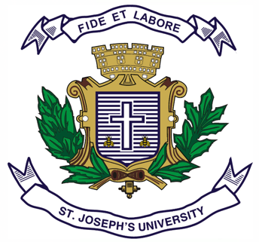

Registration Number:

Date & session:

Registration Number:

Date & session:

**ST.JOSEPH’S UNIVERSITY, BENGALURU -27**

**B.A. INDUSTRIAL RELATIONS-II SEMESTER**

**SEMESTER EXAMINATION: APRIL 2024**

**(Examination conducted in May 2024)**

**IR 2121: HUMAN RESOURCE MANAGEMENT**

**(For Current batch and Supplementary students)**

**Time: 2 Hours Max Marks: 60**

**This paper contains TWO printed pages and THREE parts**

**PART-A**

**Answer any TEN questions: (10x2=20)**

1. Define Human Resource Management.
2. In Talent Acquisition, what comes first – Recruitment or Selection?
3. What is the meaning of Learning?
4. What is Performance Appraisal?
5. Expand IHRM and E- HRM.
6. What is Demotion?
7. Explain MNC.
8. What is Transfer?
9. What is up- skilling?
10. What is the Meaning of Work Life Balance?
11. Define Human Resource Audit.
12. Mention any two types of Transfers.

**PART-B**

**Answer any FIVE questions: (5x5=25)**

13. Write Short notes on Merit Vs Seniority Criteria of Promotion.

14. Mention how HRM is a multi-disciplinary subject.

15. Write short notes on Skilling and Reskilling.

16. What are the advantages and disadvantages of Performance Appraisal?

17. What is the importance of Learning?

18. Give details of the new challenges of Human Resource Management in the light of Covid- 19 Pandemic

19. What are the reasons for demotion?

**PART-C**

**Answer any ONE question: (1x15=15)**

20.Write an essay on any One Method of Performance Appraisal.

21. What are the various functions performed by H.R Managers in the Organization OR

Write an essay on the Selection process of a candidate in the organization.