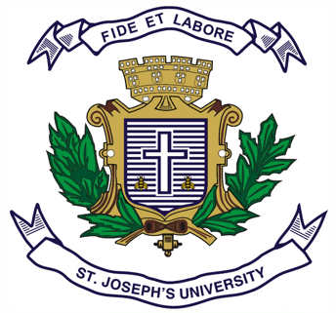

Registration Number:

Date & session:

Registration Number:

Date & session:

**ST JOSEPH’S UNIVERSITY, BENGALURU -27**

**B.A (POLITICAL SCIENCE) – 2nd SEMESTER**

**SEMESTER EXAMINATION: APRIL 2024**

**(Examination conducted in May / June 2024)**

**PS 2221: INDIAN NATIONAL MOVEMENT AND CONSTITUTIONAL DEVELOPMENT**

**(FOR CURRENT BATCH STUDENTS ONLY)**

**Time: 2 Hours Max Marks: 60**

**This paper contains Two printed pages and Three parts**

**PART-A**

I Answer any five of the following questions in about 30 to 40 words each (5x3=15)

1. What is Delhi-Lahore Conspiracy case of 1912?
2. Mention the subjects which were brought under the jurisdiction of the Provincial Government by the Mont-Ford Reforms.
3. What were the two Special features of the Cabinet Mission Plan?
4. Write a short note on the First Round Table Conference.
5. What were the views expressed by Brajewar Prasad in the Constituent Assembly on the issue of Citizenship?
6. How were the Constituent Units of the Indian Union classified, when the new constitution came into force in the year 1950?
7. What were the views expressed by Govind Ballabh Panth in the Constituent Assembly on the issue of Minorities?

**PART-B**

**II** Answer any three of the following questions in about 150 to 200 words each (3x7=21)

1. Explain the features and impact of Civil dis-obedience movement.
2. Discuss the background and contents of Nehru Report.
3. Explain the background and features of Indian Independence Act, 1947.
4. Bring out the contents of Articles 5 & 6 pertaining to Citizenship,at the commencement of the Constitution.
5. Bring out the views expressed by N.Gopal Swamy Ayyanger, Naziruddin Ahamad and S.V.Krishna Moorthy Rao in the Constituent Assembly on the issue of Language in administration.

**PART-C**

**III** Answer any two of the following questions in about 250 to 300 words each (2x12=24)

1. Bring out the features of the Government of India Act of 1935.
2. Elucidate on the constituent assembly Debate on the issue of Uniform Civil Code.
3. ‘India is a Union of State’. Discuss.