**ST JOSEPH’S COLLEGE, BENGALURU -27**

Registration Number:

Date & Session:

**B.Sc. Biotechnology- VI SEMESTER**

**SEMESTER EXAMINATION: APRIL 2024**

**(Examination conducted in May 2024)**

**BT6123: BIOPROCESS TECHNOLOGY AND ENTREPRENEURSHIP**

**(For current batch students only)**

**Time: 2 Hours Max Marks: 60**

**This paper contains TWO printed pages and THREE parts**

**PART A**

**Answer any TEN of the following: 2m x 10 = 20 marks**

1. What are batch cultures?
2. What are bulk enzymes?
3. State two important biological processes that need to be researched in selecting a fermenter.
4. What is an antifoam agent?
5. Why is water management important in a fermentation industry?
6. Identify the following part (given in the image below with a line projected from it) in a fermenter vessel. State any two applications?

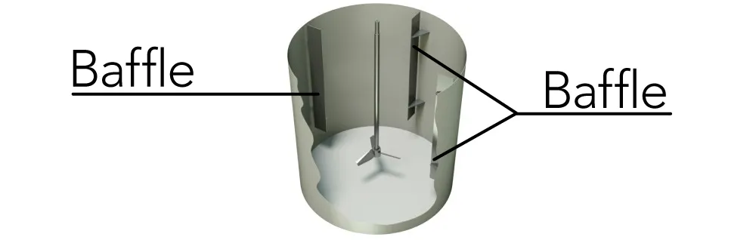

**?**

1. State any two problems associated with cooling jackets.
2. What is the importance of a transport media?
3. How can you use ammonium sulfate to purify a product?
4. What are single cell proteins? Give an example of the source.
5. Name the microorganism and culture media used in production of citric acid.
6. State two ways by which mutations in microorganisms can be beneficial for increased product output.

**PART B**

**Answer any FOUR of the following: 5m x 4 = 20 marks**

1. Draw a neat labeled diagram of a trickle bed fermenter.
2. Explain the steps involved in the industrial production of penicillin.
3. What are the basic steps involved in surface sterilization of explants?
4. The following materials need to be sterilized before being used for product formation: a) glassware, b) culture media with a growth factor and c) culture media without a growth factor. Which sterilization technique would you select for each of these and why?
5. How will you concentrate and purify a product with protein contaminants?
6. Explain the industrial uses of amylase.

**PART C**

**Answer any TWO of the following: 10m x 2 =20 marks**

1. Explain the advantages and disadvantages of hosts in context to using them for industrial level product manufacturing processes.
2. Identify the customer segments, key resources and key activities for the venture displayed below. Construct the answer such that you were the marketing group for this venture. (2+4+4)

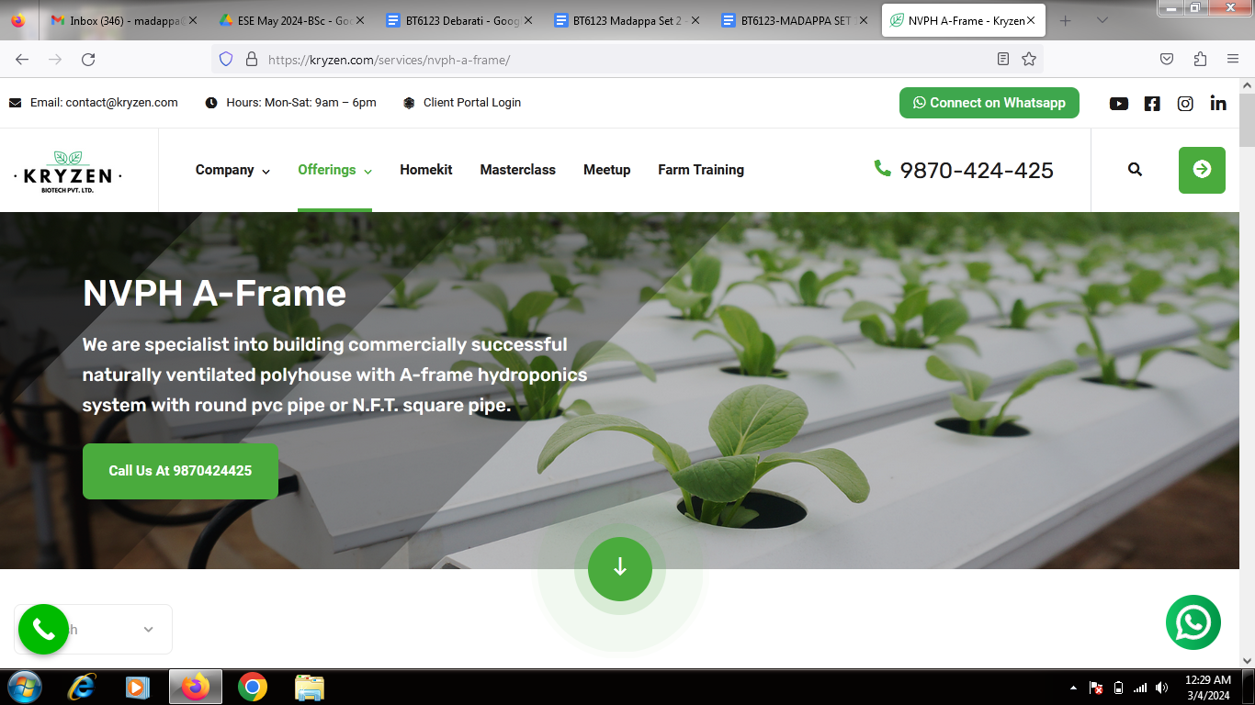

*Source: https://kryzen.com/services*

1. With respect to strain improvement answer the following:
   1. State any two factors of product formation that can be modulated by strain improvement. (2 marks)
   2. How can you use the Ames test for selection of a mutagenic compound? (3 marks)
   3. You have two strains of yeast, Y1 and Y2, for the production of wine. Y1 utilizes grapes with lower sucrose levels but produces a wine with a low alcohol content. Y2 utilizes grapes with only high sucrose levels but produces a wine with higher alcohol content. Which strain of yeast will you select for the production of this wine and why? (5 marks)

BT6123-C-24