

Registration Number:

Date & session:

Registration Number:

Date & session:

**ST. JOSEPH’S UNIVERSITY, BENGALURU-27**

**B.Sc. (MICROBIOLOGY) – II SEMESTER**

**SEMESTER EXAMINATION: APRIL 2024**

**(Examination conducted in May/June 2024)**

**MB 221: Microbial Biochemistry and Analytical Techniques**

**(For current batch students only)**

**Time: 2 Hours Max Marks: 60**

**This paper contains 2 printed pages and 4 parts.**

**I. Answer any FIVE of the following. 5 x 3 = 15**

1. Deficiency of which vitamins will cause the following diseases?  
   (i) Scurvy (ii) Osteomalacia (iii) Xerophthalmia
2. What is the Shine-Dalgarno sequence? Discuss its importance.
3. Briefly describe the principle of density gradient centrifugation.
4. Draw the structure of (i) an amino acid with a negatively charged side chain (ii) an amino acid with a positively charged side chain with an imidazole group.
5. Define: (a) porphyrins (b) triacylglycerols (c) Racemic mixture
6. Calculate the isoelectric point for the titration of Aspartate. Given that the pK1 (COOH) is 1.88, pK2 (NH3+) is 9.60 and pKR is 3.65.
7. Draw the structure of the following fatty acid: 18:2 (∆9,12)

**II. Answer any FIVE of the following. 5 x 6 = 30**

1. Identify the functional groups A, B, C, D and E in the structure below: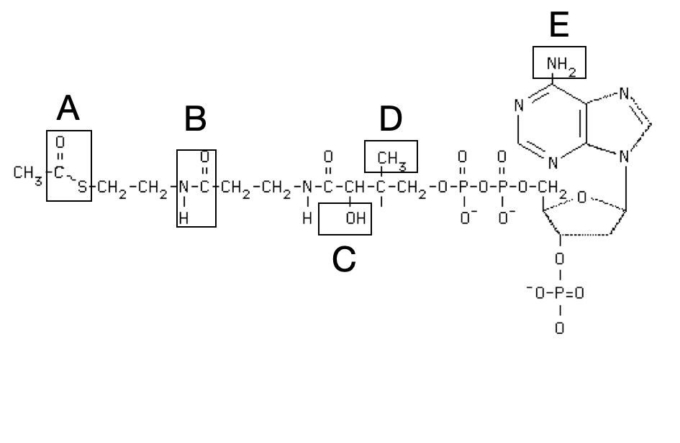
2. Compare and contrast between B-DNA and Z-DNA based on any six features.
3. Describe the Hershey-Chase experiment which demonstrated that DNA is the genetic material.
4. Discuss the factors affecting the stability of an Alpha helix.
5. Derive the Henderson Hasselbalch equation and state its importance.
6. A size exclusion chromatography experiment was carried out and the following peaks were obtained for samples A, B and C. Arrange A, B and C according to decreasing size of the molecules. Justify your answer.

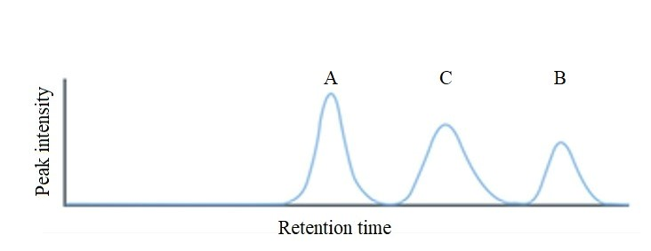

14. What is PAGE? What is it typically used for? Differentiate between native-PAGE and

SDS- PAGE. Briefly explain the role of TEMED in a PAGE set up.

**III. Answer any ONE of the following. 1 x 10 = 10**

15**.** Name the bonds/interactions:

(a) Bonds connecting two or more amino acids to form an oligopeptide.

(b) Bonds primarily responsible for stabilizing the β-pleated sheet structure in proteins.

(c) Bonds connecting two or more nucleotides to form a DNA strand.

(d) Bonds between Adenine and Thymine or Cytosine and Guanine in ds DNA.

(e) Covalent bond between the glucose and galactose in lactose structure.

(f) High energy bonds in ATP

(g) Bond between two molecules of cysteine to form cystine.

(h) Interaction important for ion-exchange chromatography.

(i) Interactions between non-polar side chains of Leucine and Valine.

(j) Bonds at the branch points of glycogen.

16. (a) What are Eicosanoids? What is their parent molecule? Name the three classes of eicosanoids. (5)

(b) Explain Beer-Lambert’s law. (5)

**IV. Answer the following. 1 x 5 = 5**

17. I have three DNA samples of the following fragment sizes:

A: 100 bp, B: 3000 bp and C: 5000 bp.

My friend gave me three conical flasks with agarose solutions (1%, 1.5% and 2%, respectively). What percent agarose gel should I preferably use for which sample to perform agarose gel electrophoresis? (3) If you ran all the three samples on a single gel, where will the position of act fragment be? (2)