 **ST JOSEPH’S UNIVERSITY, BENGALURU - 27**

Registration Number:

Date & Session:

**B.Sc. MICROBIOLOGY – 4th SEMESTER**

**SEMESTER EXAMINATION: APRIL 2024**

**(Examination conducted in May /June 2024)**

**MB 422: MICROBIAL ENZYMOLOGY AND METABOLISM**

**(For current batch students only)**

**Time: 2 Hours Max. Marks: 60**

**This paper contains 2 printed pages and 4 parts**

**I. Answer any Five of the following 5x3=15**

1. How does cofactor enhance the rate of enzyme catalyzed reaction?
2. Give a comparative account of aerobic respiration with anaerobic respiration.
3. Define allostery and cooperativity.
4. What is substrate level phosphorylation? Give one example.
5. Illustrate anoxygenic photosynthesis.
6. What is Pasteur effect?
7. Write the reaction catalyzed by Phosphofructo kinase I and pyruvate dehydrogenase.

**II. Answer any Five of the following 5x6=30**

1. How do you study the effect of pH on enzyme activity? Discuss the effect of pH on enzyme activity.
2. Give an overview of the applications of enzymes in the field of medicine.
3. Illustrate Pentose phosphate pathway.
4. Describe electron transport chain with the help of a neat diagram.
5. Create a table that lists some of the common fermentation pathways and their products, and gives examples of their importance.
6. What is dissimilatory nitrate reduction? Show the steps involved in the process.
7. Describe nitrogen assimilation.

**III. Answer any One of the following 1x10=10**

1. a. What does the Vmax and Km of enzyme catalyzed reaction signify. Discuss the data given in the table below. 5m

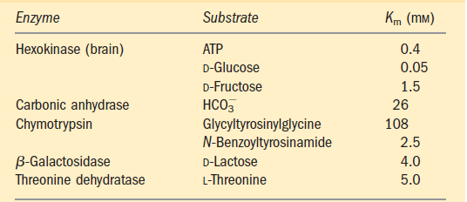

b. What is enzyme inhibition? Discuss competitive inhibition. 5m

1. a. What is the fate of pyruvate produced during glycolysis? 5m

b. What is methanogenesis? Describe the role of bacteria in the production of methane. 5m

**IV. Answer the following 1x5=5**

1. A vendor sells purified enzyme along with the buffer used for the chemical reaction. Vendor also specifies, temperature, pH and other chemical factors required for the reaction. What experiments do you think the researcher had performed to characterize the enzyme.