ST JOSEPH’S UNIVERSITY, BENGALURU-27
I M.Sc., BOTANY – II SEMESTER
SEMESTER EXAMINATION: APRIL 2024
(Examination conducted in May/June 2024)
BO8123: Paleobotany, Palynology & Plant Anatomy
(For current batch students only)
Time: 2 Hours Max Marks: 50

This paper contains ONE printed page and THREE parts.
Draw diagrams and write examples wherever necessary.

- Answer ANY FIVE of the following in two or three sentences 5 × 2 = 10
- What are concentric bundles?
- Describe pollen of Acacia.
- What is Heart wood?
- Comment on Thiruvakkarai fossil wood park.
- Describe early Angiosperms.
- Describe trilacunar node.
- Any two salient features of NPC system of classification.

- Write critical notes on ANY FIVE of the following 5 × 6 = 30
- Discuss the methods used for pollen monitoring in Aerobiology?
- Explain melittopalynology
- Discuss on the exploration of coal
- Explain the xylem elements
- Explain the abnormal secondary growth in Bignonia
- Discuss on the cytohistological zonation of shoot apex and its Tunica and corpus organisation
- Leaves show amphistomatic, undifferentiated mesophyll region with unique epidermal cell assisting in rolling of leaf. Identify the type of leaf and schematically represent the leaf internal structure.

- Give a comprehensive account of ANY ONE of the following 1 × 10 = 10

- A) plant named “A” consists of cellulose (9-25%), hemicellulose (25%-50%), pectic (10-35%) and proteins (10%); β 1-4 mannans, β 1-3 xylans and chitin with amorphous matrix; while secondary wall is of cellulose, lignin, suberin, pectin, hemicellulose, fats and waxes, lignins in considerable amount. Extensins made up of lysine, glycine, and proline.

While another plant named “B” consists of cellulose (4%), hemicellulose (2%), pectic (4%) and proteins (90%), β 1-4 mannans, β 1-3 xylans and chitin (0% each); while secondary wall is of cellulose, lignin, suberin, pectin, hemicellulose, fats and waxes and lignins in negligible amount or nil. Extensins are not formed.

Compare between the above plants ‘A’ and ‘B’ and answer the following:
- Which plant would have very thin or inconspicuous cell wall layer? Why? (1 mark)
- In which plant you will find distinguishable complex cell wall layer formation? (1 mark)
- Which among the plants will show good cell plasticity and elasticity property? Why? (1 mark)
- Which plant and its constituents will yield a general model for plant cell wall layer formation and schematically represent the cell wall layers? (2 marks)

15. B) identify the plant apex layers and explain their organisation in relevance to a hypothesis
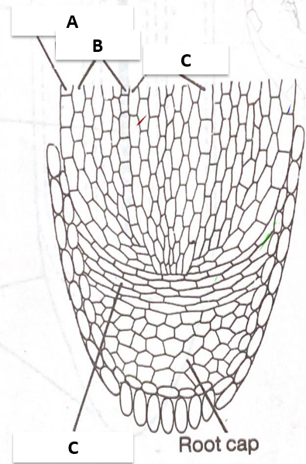

- A) Write a schematic depiction of acetolysis technique and briefly explain its significance.
B) List out any five types of fossils and briefly explain.

BO8123_A_2024

