**ST JOSEPH’S UNIVERSITY, BENGALURU -27**

Registration Number:

Date & session:

**M.Sc (ZOOLOGY) – 2nd SEMESTER**

**SEMESTER EXAMINATION: APRIL 2024**

**(Examination conducted in May / June 2024)**

**ZO 8122 – BIOLOGY AND DIVERSITY OF CHORDATES**

**(For current batch students only)**

**Time: 2 Hours Max Marks: 50**

**This paper contains TWO printed pages and FOUR parts**

**PART-A**

**Answer the following questions (5 x 1 = 5)**

1. Mention two features that enabled jawless fishes to become mobile predators.
2. Which is the accessory respiratory organ present in Anabas?
3. Herbivorous quadrupedal dinosaurs are placed under which reptilian suborder?
4. Name the unpaired respiratory air sacs present in birds.
5. Comment on the role of the sense organs depicted in the fishes below

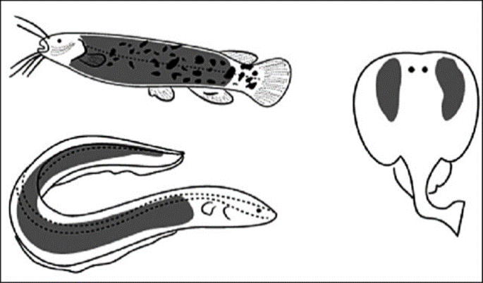

**PART – B**

**Answer the following questions (5 x 2 = 10)**

1. Placoderms represent an "early experiment" in the evolution of jawed fish. Why?
2. Depict the classification indicating the relationship between cyclostomes and gnathostomes based on craniate theory.
3. How palaeognathous and schizognathous bird palate differs with respect to palatine bone?
4. Complete the cladogram by dragging the labels to the correct spot and represent with the options filled in the boxes.

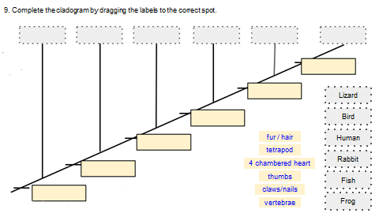

1. What is median eye? Mention its occurrence in vertebrates.

**PART - C**

**Answer any THREE of the following questions (3 x 5 = 15)**

1. List the distinct features of chondrichtyes and give their outline classification.
2. Why are ostracoderms called so?. Discuss the different reasons for their heavy armour.
3. Give an account of gustatory organs in vertebrates
4. Describe the structure of a vertebra with suitable illustration.
5. Describe the poison apparatus in snake.

**PART - D**

**Answer any TWO of the following questions (2 x 10 = 20)**

1. Give a schematic representation of the neuro-endocrine control of Amphibian metamorphosis
2. a. Discuss the evolutionary significance of dipnoi (5)

b. Briefly explain the sequence involved in catadromous migration (5)

1. What a note on the mechanism of adaptive radiation and discuss the types of adaptive radiation found among class mammalia.

*******