**ST JOSEPH’S UNIVERSITY, BENGALURU -27**

Registration Number:

Date & session:

**M.Sc. (ZOOLOGY) – 2nd SEMESTER**

**SEMESTER EXAMINATION: APRIL 2024**

**(Examination conducted in May / June 2024)**

**ZO 8422 – HISTOLOGY, HISTOCHEMISTRY AND HISTOPATHOLOGY**

**(For current batch students only)**

**Time: 2 Hours Max Marks: 50**

**This paper contains 03 printed pages and 04 parts**

**PART- A**

Answer **all the FIVE** questions **5 X 1=5**

1. Identity the below reaction with reference to localization of nucleic acid by Feulgen reaction.

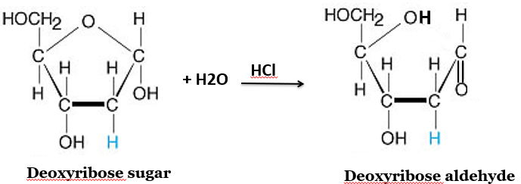

1. What is the histopathological hallmark of IDC-P?
2. The formula given below represent -------------- of the fixation. Expand the components in the formula.

**d = K√t**

1. Name the canals that pierce the bone matrix and communicates with Haversian canals.
2. Complete the reaction given below.

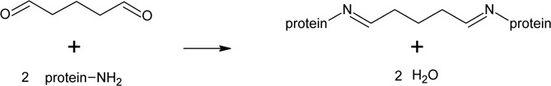

**PART- B**

Answer **all the FIVE** questions **5 X 2 = 10**

1. Mention the composition of Zenkar's fluid.
2. Describe Hassall’s corpuscles.
3. What is the method used in plate-B and mention it's consequences.

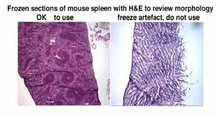

**A**

**B**

1. Explain the molecular organization of N-CAM and E-CAM.
2. What is the critical feature of testicular seminoma?

**PART- C**

Answer **any THREE** of the flowing **3 X 5 = 15**

1. How methylene bridges are formed by formaldehyde? explain with chemical reactions.
2. Write a short note on non-malignant neoplasm.
3. Explain the principle involved in the localization of steroid dehydrogenase activity.
4. Give an account on the pathophysiology of atherosclerosis.
5. How immunohistochemistry is useful in identifying the cell types of 1, 2, 3 and 5 plates of classic islets in rat pancreas stained by immunoperoxidase method? Identify the cell types in all the four plates.

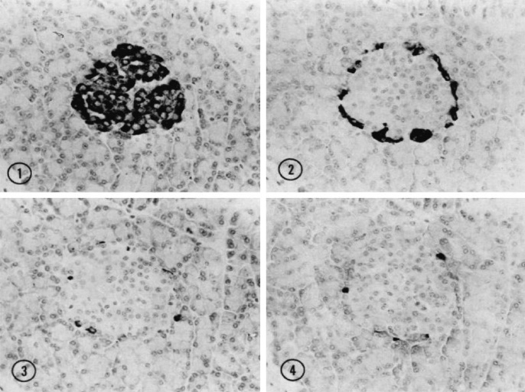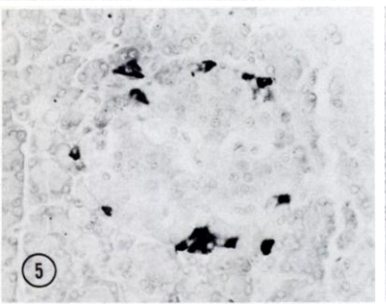

**PART- D**

Answer **any TWO** of the following questions **2 X10 = 20**

1. Provide a detailed histo-morphological features of mammalian ovary with a neat labelled diagram.
2. Differentiate dye from stain. ‘Naturally obtained hematoxylin is not a dye’, substantiate the statement and explain how hematoxylin is converted into active dye?
3. Discuss the critical causes and types of tissue degeneration by giving an emphasis on histo-morphological alterations.

----------------------------