

Registration Number:

Date & session:

**ST JOSEPH’S UNIVERSITY, BENGALURU -27**

**ZOOLOGY – 2nd SEMESTER**

**SEMESTER EXAMINATION: APRIL 2024**

**(Examination conducted in May / June 2024)**

**ZO 221 – BIOCHEMISTRY AND PHYSIOLOGY**

**(For current batch students only)**

**Time: 2 Hours Max Marks: 60**

**This paper contains 03 printed pages and 03 parts**

**PART - A**

Answerthe following **10 X 1=10**

1. Why is albumin considered as simple protein?.
2. Name the papillae of the tongue.
3. Identify the given carbohydrate

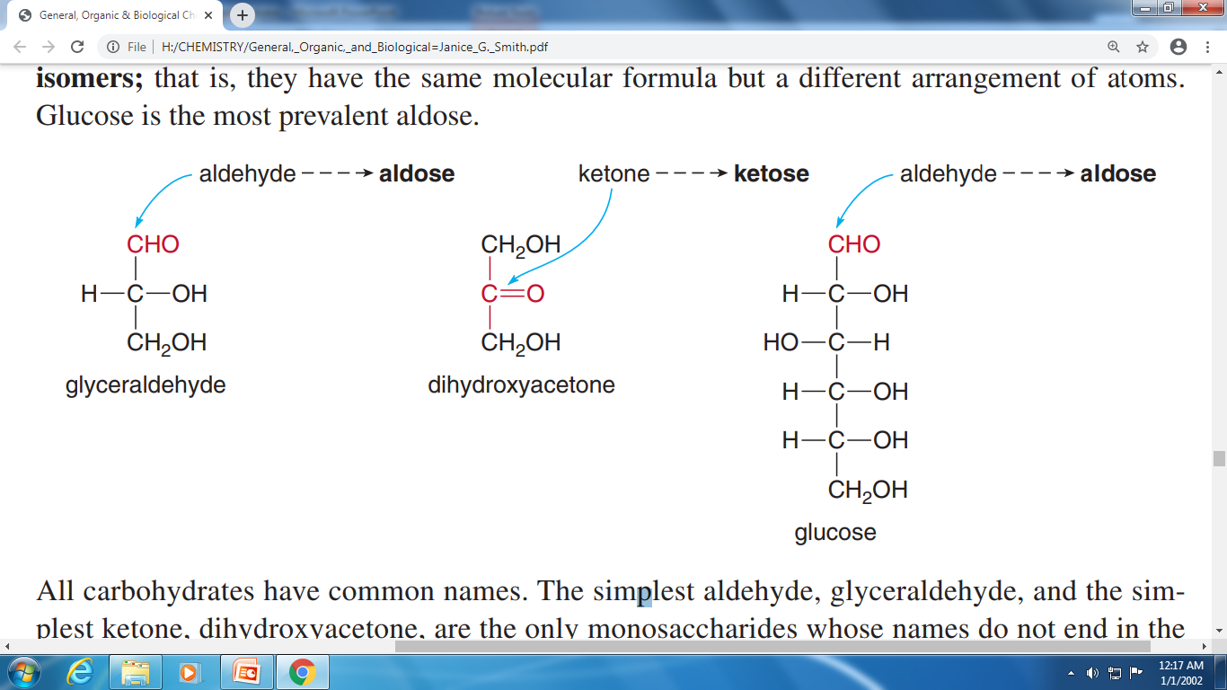

1. Give the sequence of steps involved in blood clotting.
2. Glycogenin is not a self-glycosylating enzyme. True /False.
3. What is the role of ADH in dehydration?. Give the elaboration of ADH.
4. Identify the given chemical reaction

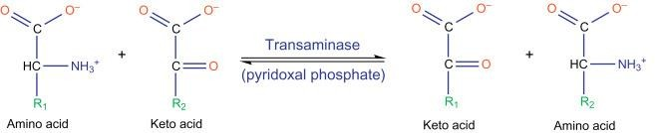

1. What does it mean if your muscles twitch?
2. An increase in substrate concentration increases the rate of an enzyme-catalyzed reaction to a certain point, thereafter the rate of reaction is no longer increased by any subsequent increase in the substrate. Substantiate the statement.
3. Identify the labeling ‘a’ and ‘b’.

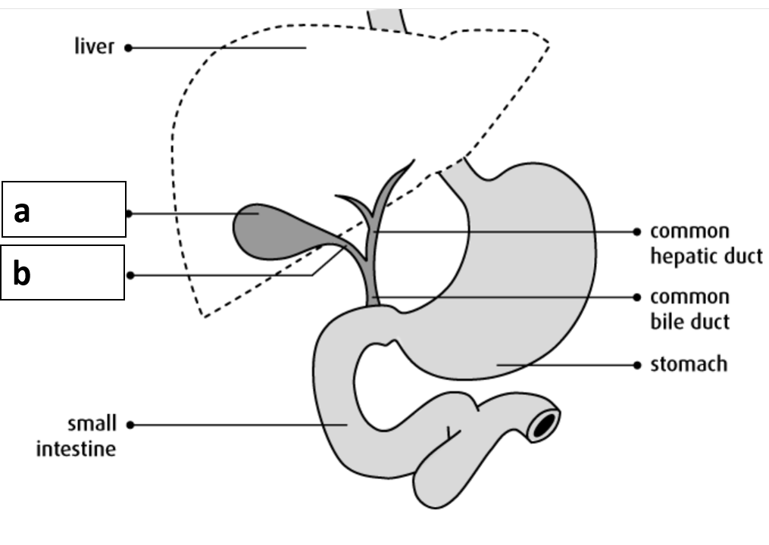

**PART - B**

Answer **any four** of the following **4 X 5=20**

1. **‘**Blood is thicker than water’. Give scientific reasoning and schematically represent the cell types of blood.
2. Identify the enzymes (labeled as 1, 2, 3, 4 and 5) involved in urea cycle

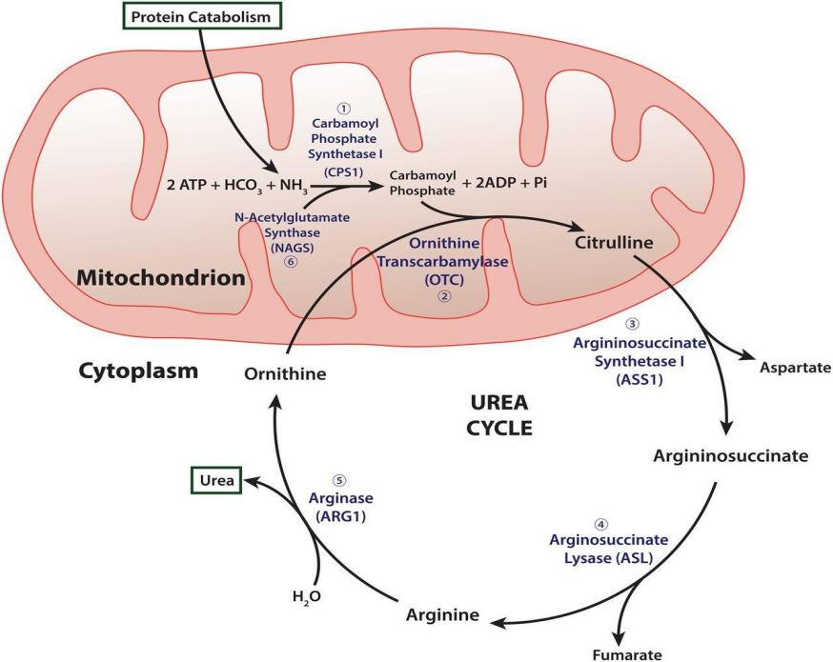

**5**

**4**

**3**

**2**

**1**

1. How do steroid hormones exert their action?.
2. Explain the quaternary structure of hemoglobin with a neat labeled diagram.
3. With a diagram, explain the structure and function of the Juxtaglomerular Apparatus.
4. Draw the structure of a phosphoglyceride found in most of animal plasma membrane and explain how fatty acid tails affect the fluidity of the membrane.

**PART - C**

Answer **any three** of the following **3 X 10=30**

1. Explain oxygen transport and depict the oxygen dissociation curve.
2. Give a schematic representation of conversion of glucose into pyruvic acid.
3. Depict and explain the steps involved in synaptic transmission
4. Explain the biosynthesis of palmitic acid.
5. a) Explain how the enzyme, ‘ATPD-glucose-6- phosphotransferase’ is named as “E.C.2.7.1.2” as per international commission on enzymes. (5m)

b) Draw and explain the components of motor unit. (5m)

-----------------