Registration number:

Date & Time:

**ST. JOSEPH’S UNIVERSITY, BENGALURU-27**

**OPEN ELECTIVE - II SEMESTER  
SEMESTER EXAMINATION: APRIL 2024**

**(Examination conducted in May / June 2024)**

**ZO OE3 – PARASITES AND COMMUNITY HEALTH**

**(For current batch students only)**

**Time: 2 h Max Marks: 60**

This paper contains **THREE** printed pages and **FOUR** parts

**PART-A**

**Answer all the following questions 20 X 1 = 20**

1. ­­­­­­__________is any type of a close and long-term biological interaction between two biological organisms of different species.
2. A parasite that lives a parasitic life when opportunity arises i.e., organisms which can live either a parasitic or non­-parasitic existence is known as?
3. 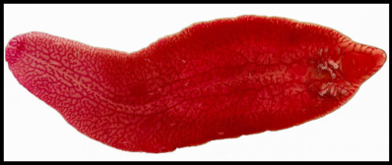 Identify the given parasite.
4. Define a definitive host with an example.
5. *Trypanosoma* is a multicellular organism. TRUE or FALSE
6. ______ is a sac like envelope which is found as a investing membrane around the larvae of Wuchereria bancrofti.
7. Nematodes use _________ to feed from plants
8. Japonica or Eastern schistosomiasis is caused by________, found in Japan, southern China, the Philippines, Thailand and Indonesia.
9. A female *Ascaris* produces roughly about how many eggs daily.
10. Life cycle of which parasitic nematode is depicted in the given figure 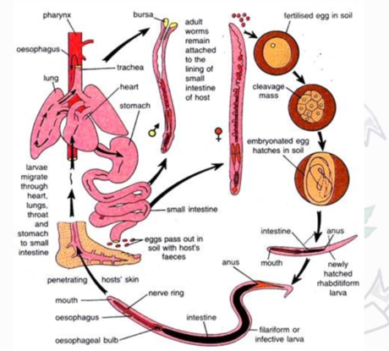
11. Draculin content is seen in the saliva of _________
12. ___________ causes a bout of dysentery called amoebic dysentery
13. Merozoites multiply asexually in the erythrocytes is known as _______________.
14. Define sexual dimorphism
15. A _______ disease is a disease spread between animals and people.
16. Mention any two treatment measures against Giardiasis.
17. What are the two types of life cycles seen in parasites
18. Schistosoma haematobium both female and male always exists as paired and looks like an individual. This condition is called?
19. Recurrent fever and constantly falling asleep is a symptom of Sleeping sickness caused by ­­­__________
20. The common head louse gets transmitted even through simple exchange of household materials. True /false

**PART-B**

**Answer all the following questions 5 X 2 = 10**

1. Define mutualism with example.
2. List few steps of prophylaxis against zoonotic diseases.
3. What are parasites? give examples.
4. What are the preventive measures used against *Plasmodium vivax?*
5. List any two symptoms and treatment against diseases caused by *Entamoeba histolytica*

**PART – C**

**Answer any FOUR from the following 4 X 5 = 20**

1. Enumerate on the mechanism of parasitism and phoresis with examples.
2. What are Pediculus? Enumerate on the biology and it control measures.
3. Define antigen and antibody. Make a note on the different types of immunoglobulins.
4. Explain the morphology, life cycle and control measures of *Trypanosoma gambiense.*
5. Explain the various stages of development seen in parasitotic beetle

**PART – D**

**Answer any ONE from the following 1 X 10 = 10**

1. What is PCR, explain the steps involved in PCR. Comment on its applications
2. Describe the sexual and asexual stages of life cycle in *Plasmodium vivax.* Add a note on the symptoms of Malaria.

**********************