

Registration Number:

Date & session:

Registration Number:

Date & session:

**ST JOSEPH’S UNIVERSITY, BENGALURU -27**

**OPEN ELECTIVE – 2nd SEMESTER**

**SEMESTER EXAMINATION: APRIL 2024**

**(Examination conducted in May / June 2024)**

**ZOOE4 – A JOURNEY INTO THE ANIMAL WORLD AND HUMAN LIFE**

**(For current batch students only)**

**Time: 2 Hours Max Marks: 60**

**This paper contains 03 printed pages and 04 parts**

**NOTE: Draw neat labeled diagram wherever necessary**

**PART - A**

Answer **all** the following **20 X 1=20**

1. Name any one of the hormones produced by ovary.
2. ---------- organ is present between esophagus and small intestine in digestive system.
3. Give an example for genetic disease.
4. Who is father of evolution?
5. The structural and functional unit of nervous system is called -------------.
6. Coronary heart disease occurs when heart's nerve supply is blocked. True /False.
7. Right lung consists of --------- number of lobes.
8. Butterfly is an invertebrate. True/False.
9. What is parasite? Give an example.
10. The below images represent --------- type of behavior in crocodiles.

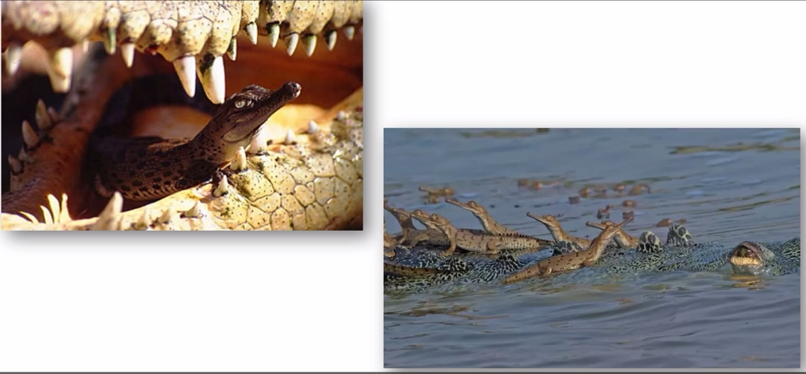

1. Anti venom is used during snake bite. True /False.
2. The below image shows which type of behavior?

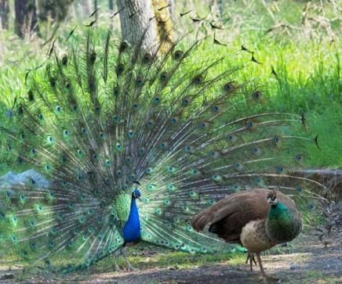

1. Name any two types of bird migration.
2. Human heart consists of ------- number of chambers.
3. Urine is formed in ------- part of excretory system.
4. Which part of male reproductive system produces spermatozoa?
5. Name any two vector borne diseases.
6. Define hyperglycemia.
7. The give image B represents which type of disease

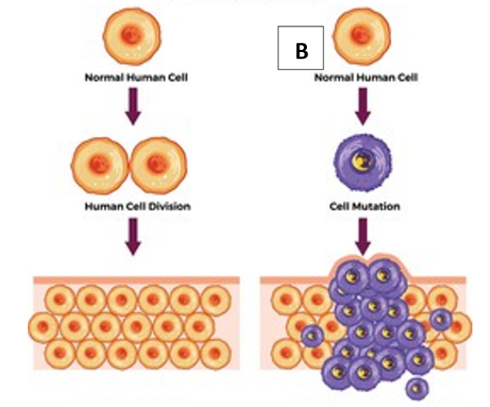

1. Noise induced hearing loss is one of the occupational health hazards. True/False.

**PART - B**

Answer **all** the following **5 X 2=10**

1. Mention any two types of cancer.
2. How kangaroo shows parental caring?
3. Mention any two poisonous snakes.
4. Identity the type of asexual reproduction in A and B.

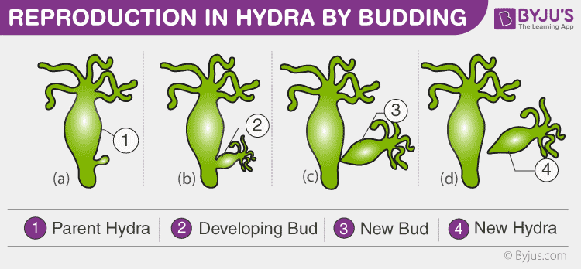

**A**

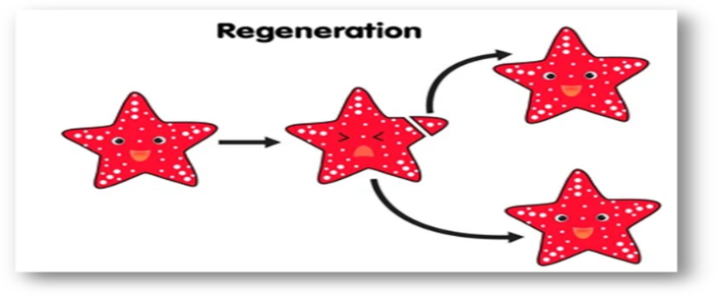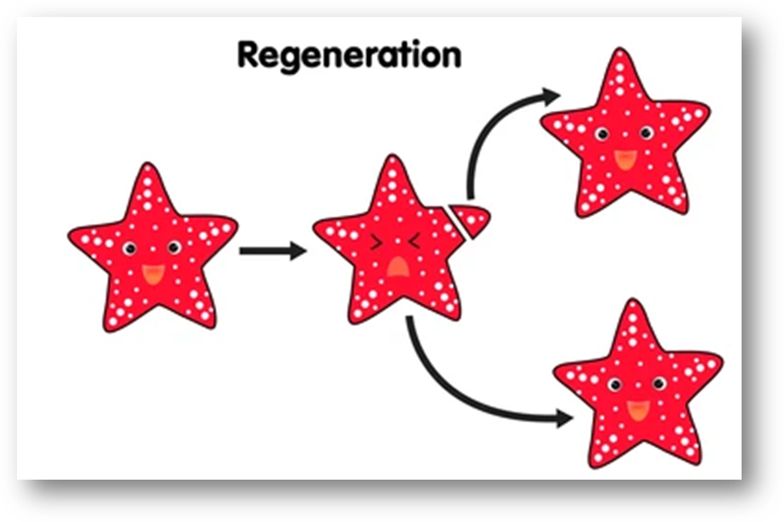

**B**

1. Mention any two economic importance of invertebrates.

**PART - C**

Answer **any four** of the following **4 X 5=20**

1. Explain ABO blood grouping system with a diagrammatic representation.
2. Draw a neat labeled diagram of human heart.
3. Identity the 5 different parts in the given image.

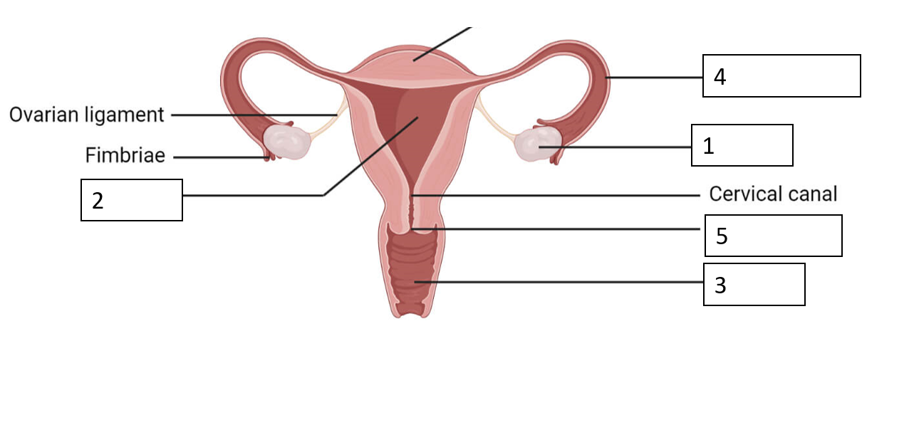

1. Explain the common causes of mental illness.
2. Explain any five modes of communicable diseases.

**PART-D**

Answer **any one** of the following **1X 10=10**

1. With a neat labeled diagram explain the functions of human respiratory system.
2. Expand AIDS. Briefly explain the mode of transmission of HIV virus and add a note on prevention and treatment of AIDS.

**----------------------**