Register Number:
Date:
ST. JOSEPH’S COLLEGE (AUTONOMOUS), BANGALORE-27
M.A. ECONOMICS - IVSEMESTER
SEMESTER EXAMINATION: APRIL 2020
EC 0118: ADVANCED ECONOMETRICS
Time: 2.5 Hours Maximum Marks - 70
This question paper has 2 printed page and 3 parts

Part A. Answer any FIVE of the following 2 X 5=10
- Differentiate between an autoregressive and a distributed lag model.
- What is simultaneous equation bias? Explain with the help of an example.
- A simple macroeconomic model consists of a consumption function and an income identity: C = α + β Y + u and Y = C + I
where C is aggregate consumption, I is aggregate investment, Y is aggregate income, and u is a disturbance term. On the assumption that I is exogenous, derive the reduced form equations for C and Y.
- Give the meaning of the term spurious regression.
- What is the difference between trend stationary and difference stationary process?
- State the advantages of panel data models over cross sectional econometric models.
- Explain the difference between OLS method and MLE method in brief.
Part B. Answer any THREE of the following 10 X 3 =30
- Discuss the adaptive expectation model.
- Explain the Two-stage least square (2SLS) method of estimating simultaneous equation with the help of an example.
- Suppose that Y_{t} is determined by the process
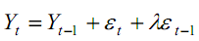
where ԑ_{t} is iid. Show that the process for $Y_{t}$ is nonstationary unless λ takes a certain value.
- Write a note on cointegration and error correction model.
- Explain the Tobit model and its estimation.
Part C. Answer any TWO of the following 15 X 2 =30

- Discuss the Koyck transformation model along with its limitations. Show how Almon’s distributed lag model is better than Koyck model.
- Explain the graphical and non-graphical ways of deciding non-stationary models and the order of AR and MA.

- State the rank and order condition for identification. Consider a four equation IS-LM model
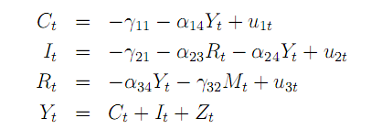
where C_{t} is consumption, $I_{t}$ is investment, R_{t} is the rate of interest, Y_{t} is income, $M_{t}$ is the money stock and $Z_{t}$ is autonomous expenditure. Check for rank and order condition for each one of the equations.

